Electrical devices WEBSITE

Web programming class project 2023

|  |  |  |  |  |
| --- | --- | --- | --- | --- |
| Student Name in English | Student Name in Arabic | Student ID | Section | Work percentage |
| Nada Jamal Ajaj | ندى جمال عجعج | 12028338 | Sun-Tue-Thu 8-9 | 50% |
| Ibtihaj Sami Assi | ابتهاج سامي عاصي | 12029066 | Sun-Tue-Thu 8-9 | 50% |
|  |  |  |  |  |

Date/time

---------------------------------------------This section is intended for the Instructor---------------------------------------

|  |  |
| --- | --- |
| **Topic** | **Mark** |
| Project Idea |  |
| Project Complexity |  |
| Project Tools |  |
| Project Requirements and Modeling |  |
| Project Discussion |  |
| Project Completeness |  |
| Project Output Results or reporting |  |
| Project Administration and Management |  |
| Project Report |  |
| Team work |  |
|  |  |

|  |  |
| --- | --- |
| **Topic** | **Mark** |
| Introduction: |  |
| Abstract |  |
| Project Requirements and Modeling |  |
| Tools used in the project |  |
| Correctness of Database mapping |  |
| Functional Dependency and Normalization |  |
| Project Tools |  |
| Project Discussion |  |
| Project Completeness |  |
| Project Output Results or reporting (JasperReport, charts, graphs, etc.) |  |
| Project Administration and Management |  |
| Project Report |  |
| Project Idea |  |
| Project Complexity |  |
| Team work |  |
|  |  |

•Abstract:

We chose to create an website for selling Electrical devices for any person want to buy these things from the owner of this website. This website will make the process easier and more faster to achieve his works in a faster and effective way without losing data and information of each table and user.

Users can buy from this website from any side of the world and admin (owner of the website) can update, edit, delete and add data and a new product to the website to be shown to the users.

This website which called (Shamout.com) has many departments for selling such as part for TV, Hair Care, Small Appliance, cards … etc.

This website offers features to allow the users to buy in an easy responsive website and another many features for the owner.

•Introduction:

* Due to the innovation of many household electrical appliances, including what helps in facilitating life and reducing time (especially for women)And the increase in specialized shops for certain types. My partner and I decided to create a website(Online store for the sale of electrical appliances) that includes all household appliances and devices for personal use. It also includes the best international brands. Prices also vary, so that this store includes low, medium and high prices.
* This site makes it easier for people to shop with less effort and time and includes everything they need. Then, with the click of a button, the purchase process is completed and delivered to the door of the house
* Project Requirements:

Project Name: Shamout.com

Project Description: creating website for selling Electrical devices.

This website contain several department and they are:

1-Home Appliance: Refrigerators, Oven, Hob, Hood, Washer, Dryer, Dishwasher.

2-Small Appliance: Floor care, Iron, Coffee & Espresso, Electric kitchen.

3-Personal & Beauty Care: Hair remover, Men razors, Hair straightener & dryer.

4-Heating & Cooling: air conditioner, Fan, Heater.

5-TV.

6-Account.

7-Shopping Cart.

**Requirements**:

Each user who will enter this website should first register in and then sign in buy the things that the website is selling has a unique email, username and password.

Admin that is the owner of the website has a unique email, username and password to enter his own pages to (add, delete, update, and edit). This admin can put fields in this website and they are (tv, oven, washer and any electrical device the website sells ).

Each kind of product has a unique id, name, prices, quantity and image.

Each user can enter any department to buy the things he want.

Each card has content, unique id, user id, quantity, total price.

Each order has a unique id, user name, user phone number, user email, method of buy, user address (flat number, street, city, country, total product, total price).

* Tools used in the project:
* MySQL + Xampp:

FOR MAKING SQL STATMENTS TO MAKE DATABSE OF THE WEBSITE.ImageImage

Image

* PHPStorm:
* Google drive:Image

Now we will go to first department in our website:

The UML for project:

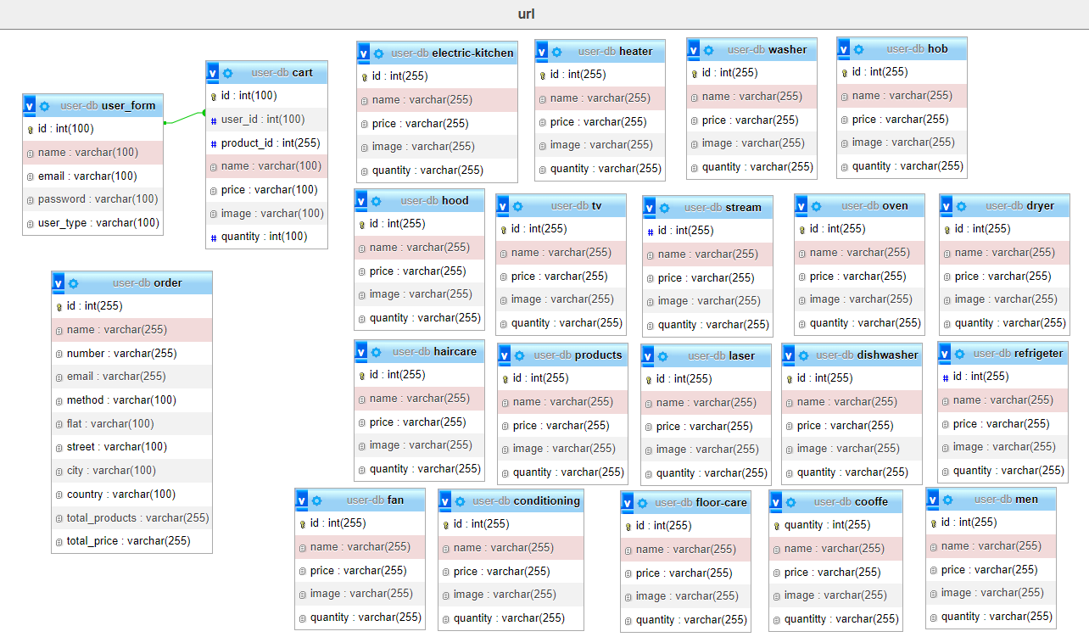

* GUI Application of the website:

-Home page-

register now page & log in:

If user enter the first time for website you should choose register now and fill your name,email,password and choose register as user or admin then click login now.

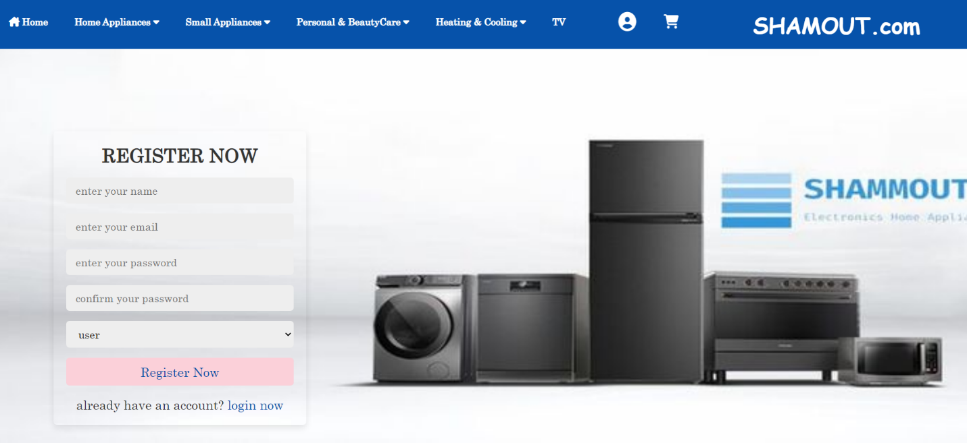

Login page contains your email and password(go for this page after register user or admin).

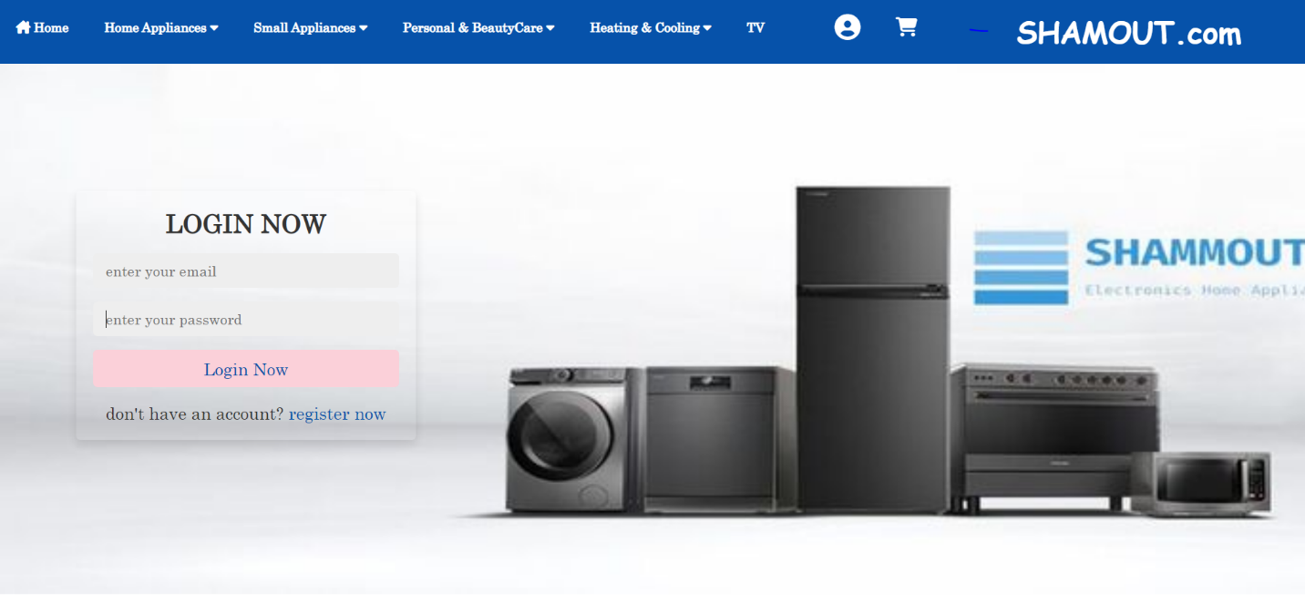

Each user and admin have a special email as shown to log in after register .

There is two sides to enter the website.

Admin side(owner of the website to delete ,add, update..etc).

User side to have a account to buy from it from the website.

-HOME PAGE if your a user-

-At first this home will be in the first page to give the user an idea about the website and to put some of the website’s purchases.

These are moving pictures to give a first idea of ​​the site.

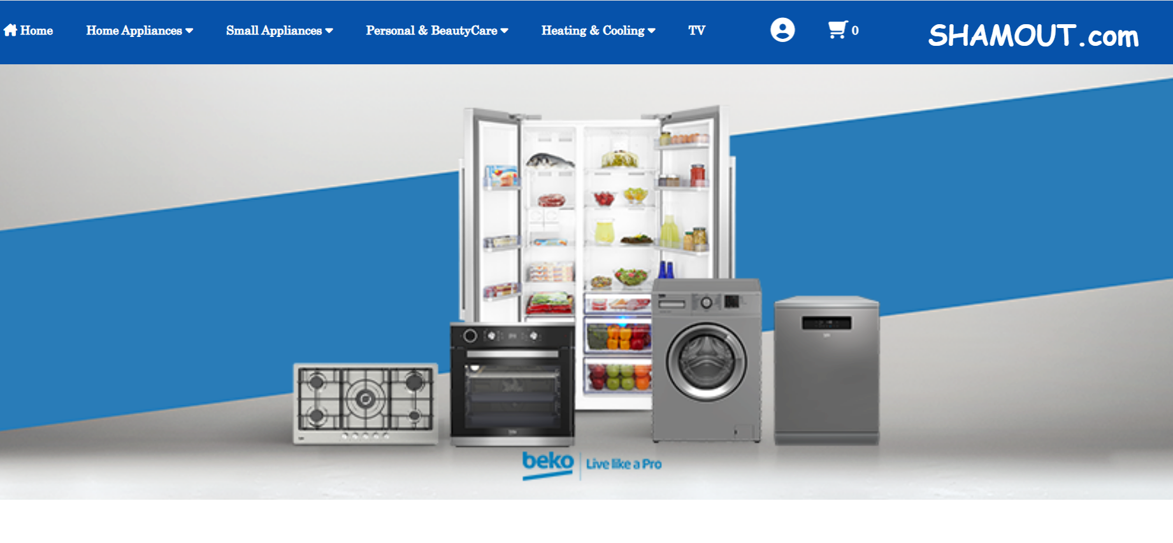

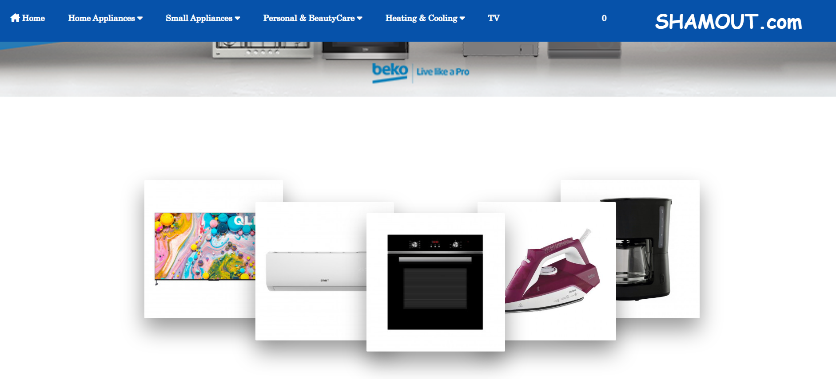

-This section enables the user to choose the brand to shop (each brand contains all its products).

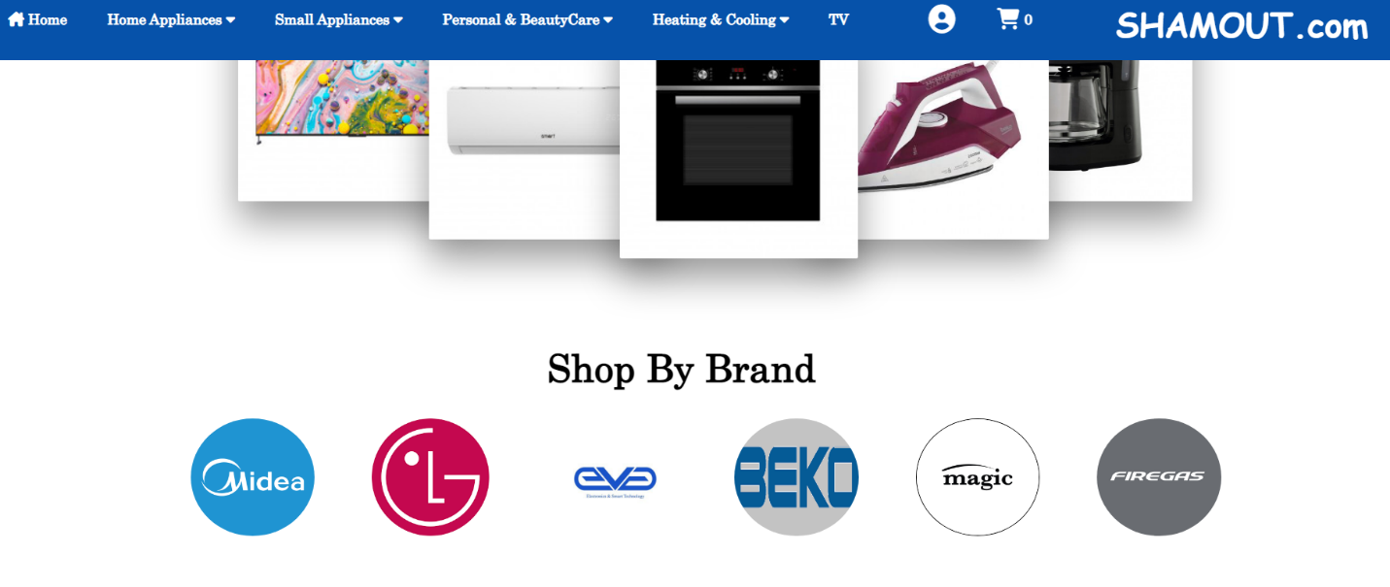

For magic:

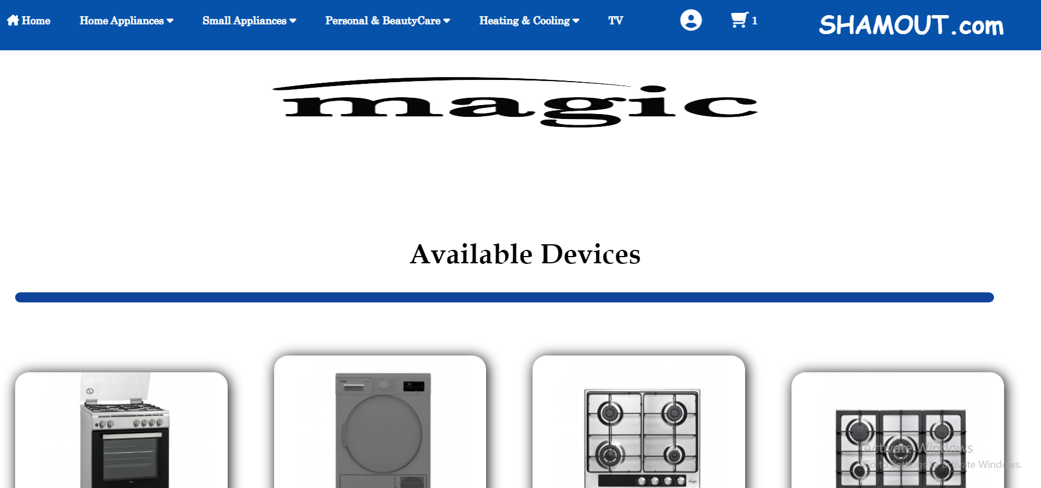

For beko:

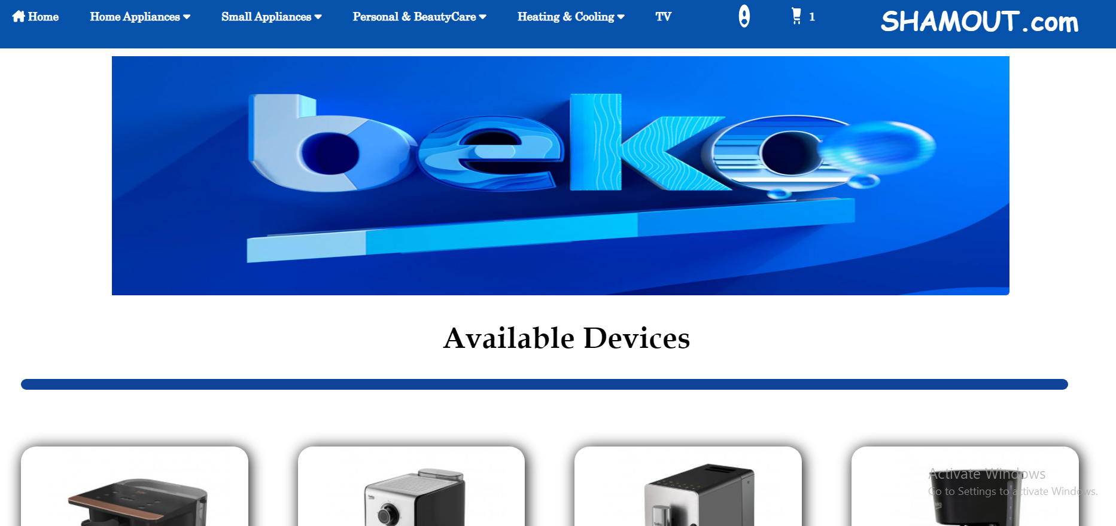

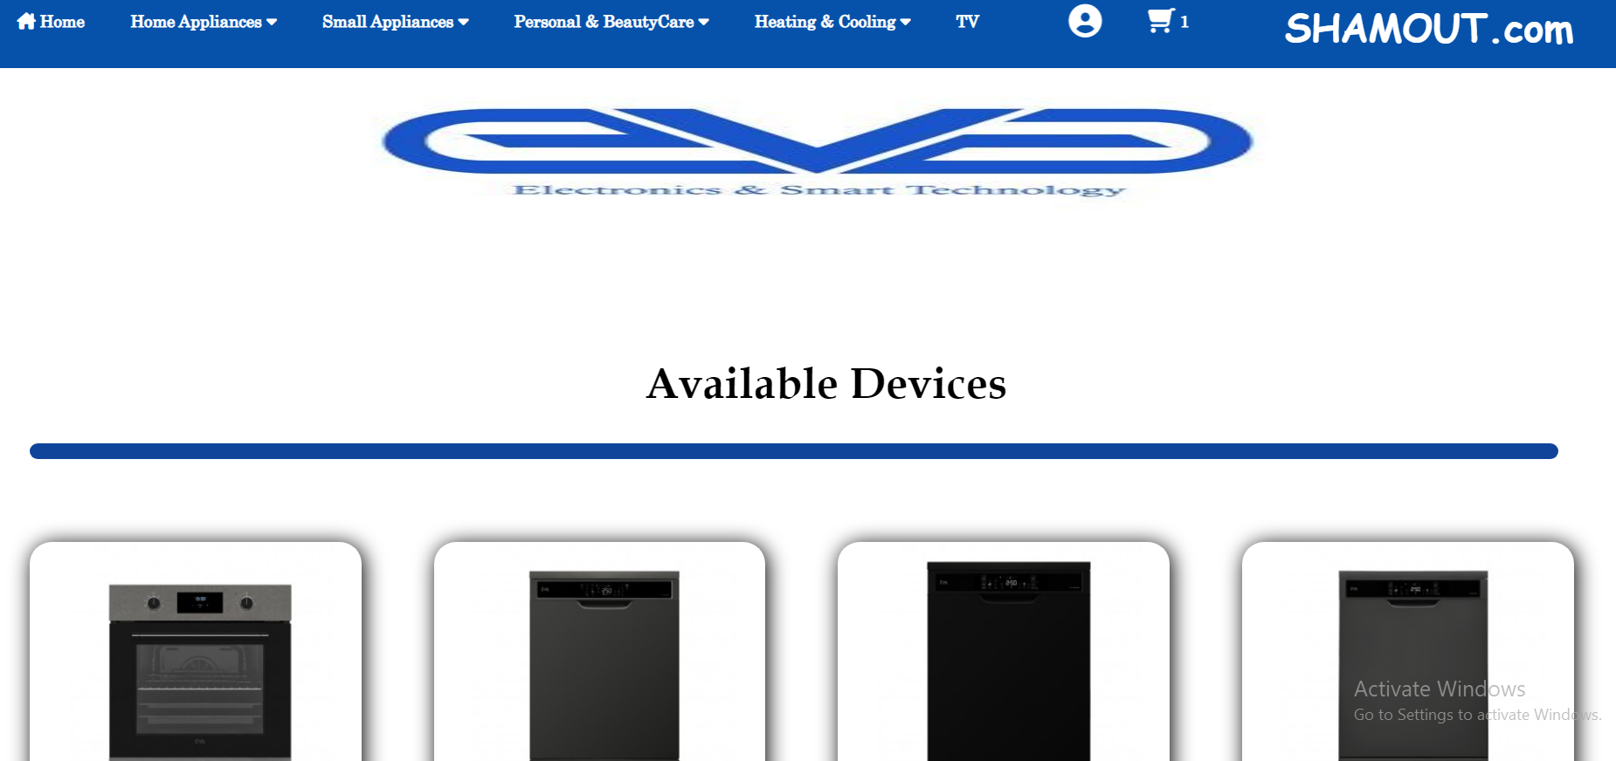

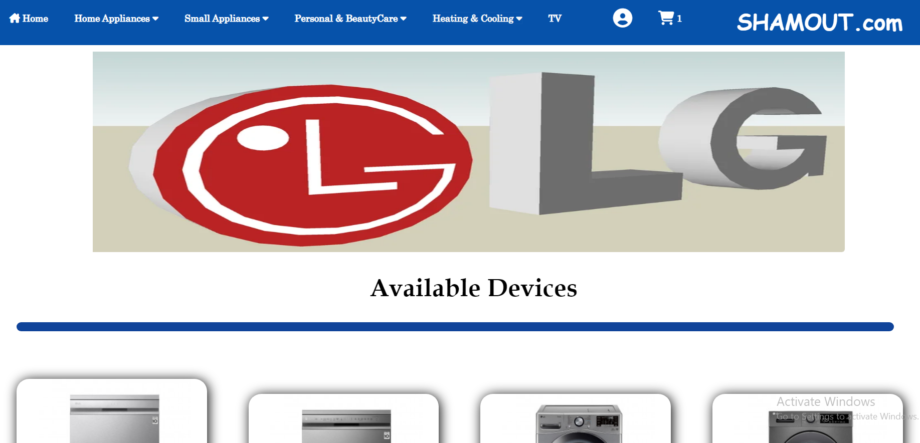

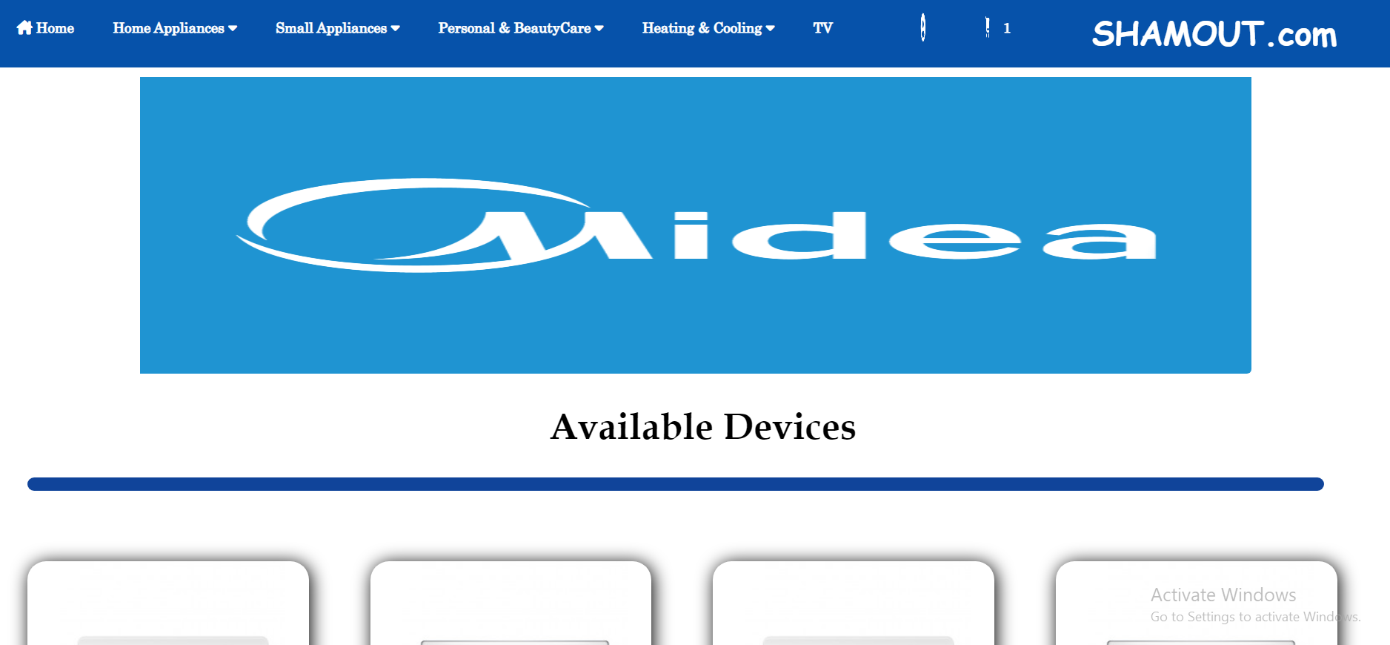

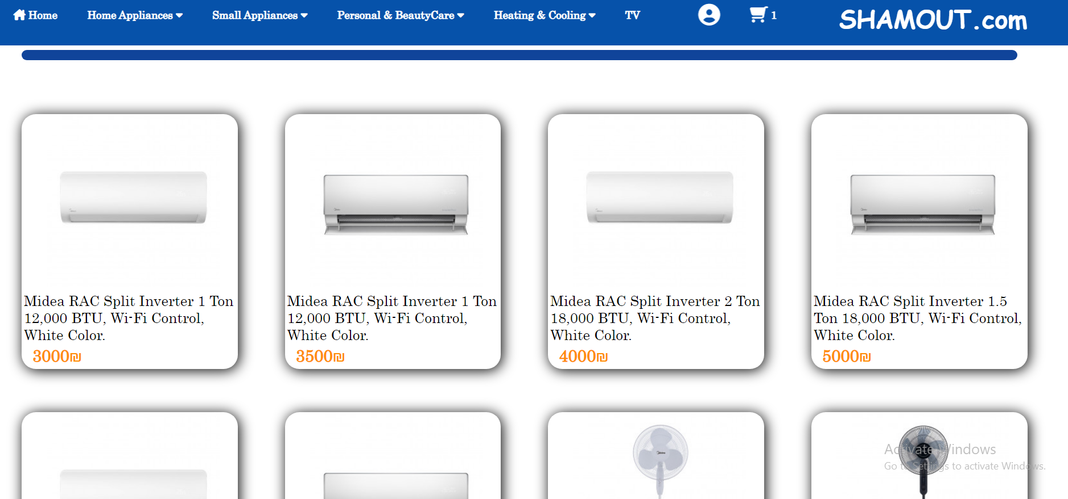

-These are a sliders to show image(It shows the description and price of this product)and if we scroll left or right you will find more images, If you place the mouse on the image, two buttons will appear, the first to show more information about the product and the second to add it to the shopping cart

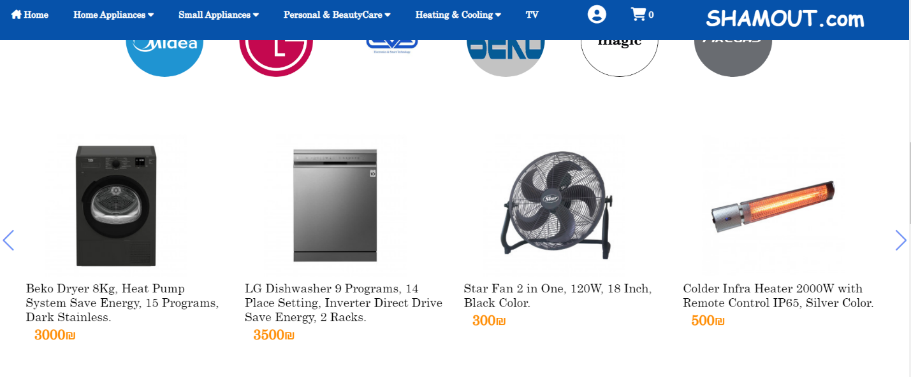

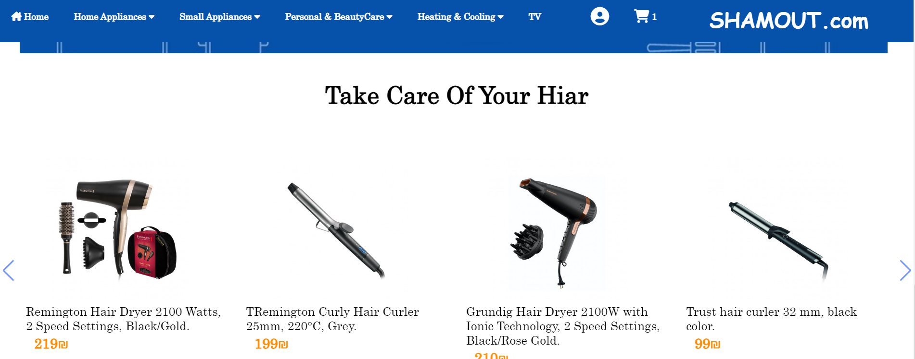

-This part through which the user can press a button(watching offers) through which a new page opens showing all the devices that have offers in different percentages

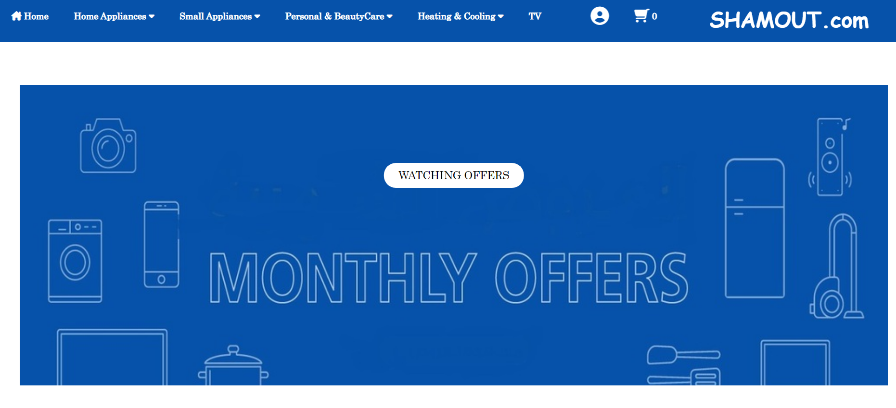

The offers pages appear like this :

If you place the mouse on the image for pro

duct, two buttons will appear, the first to show more information about the product and the second to add it to the shopping cart

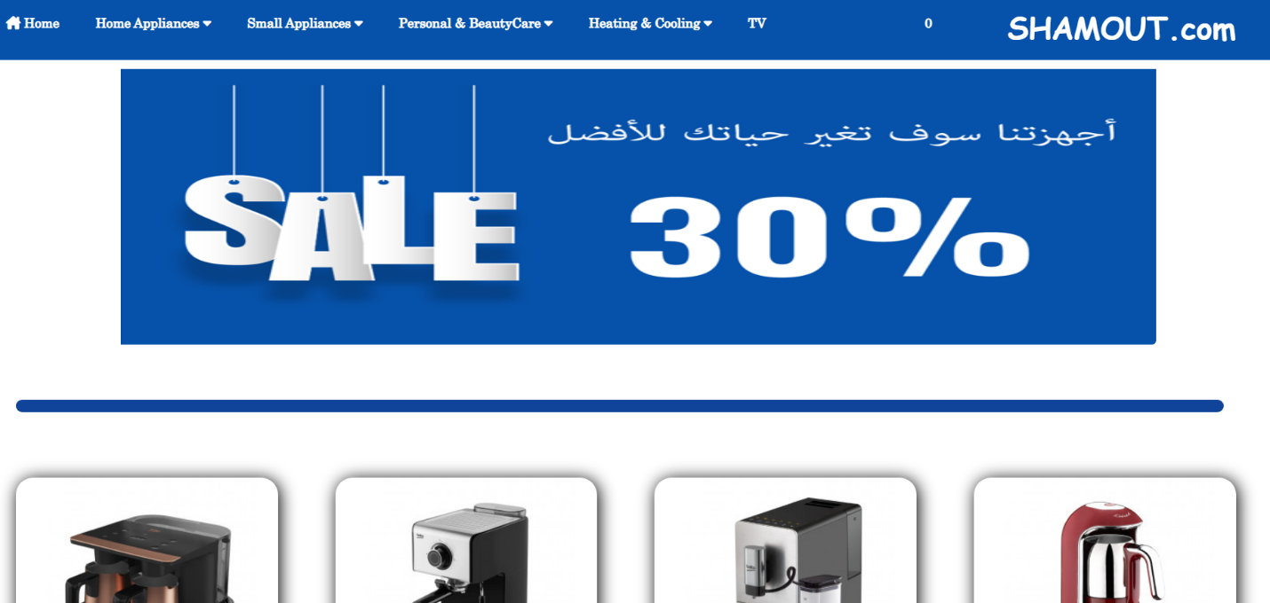

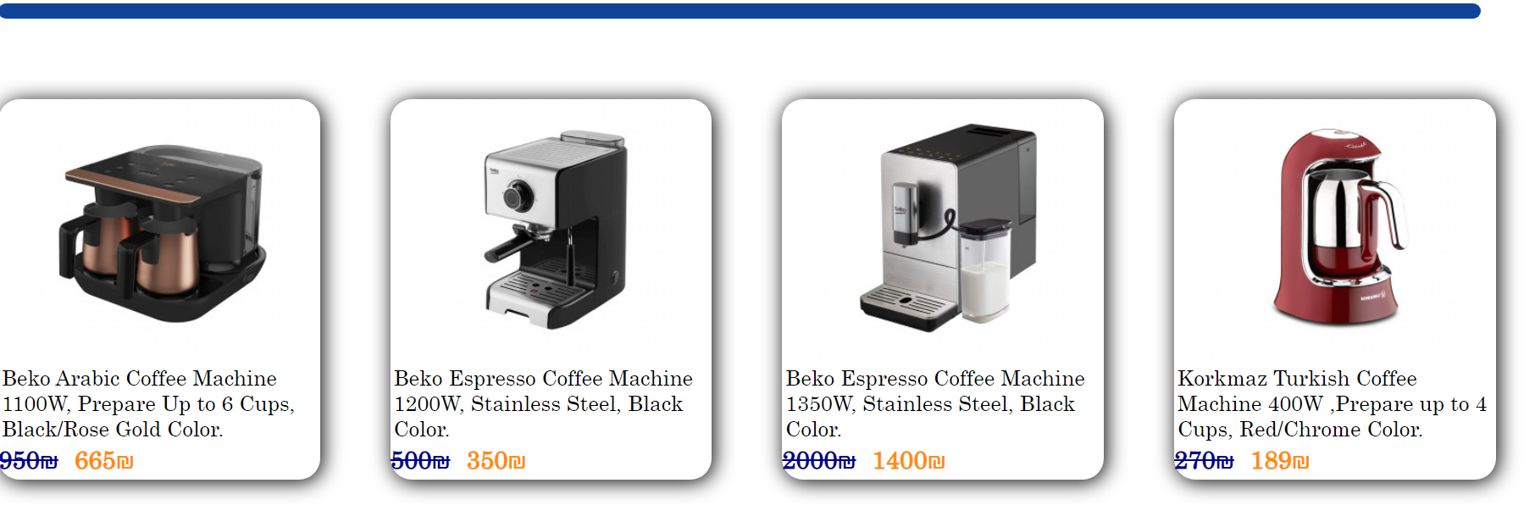

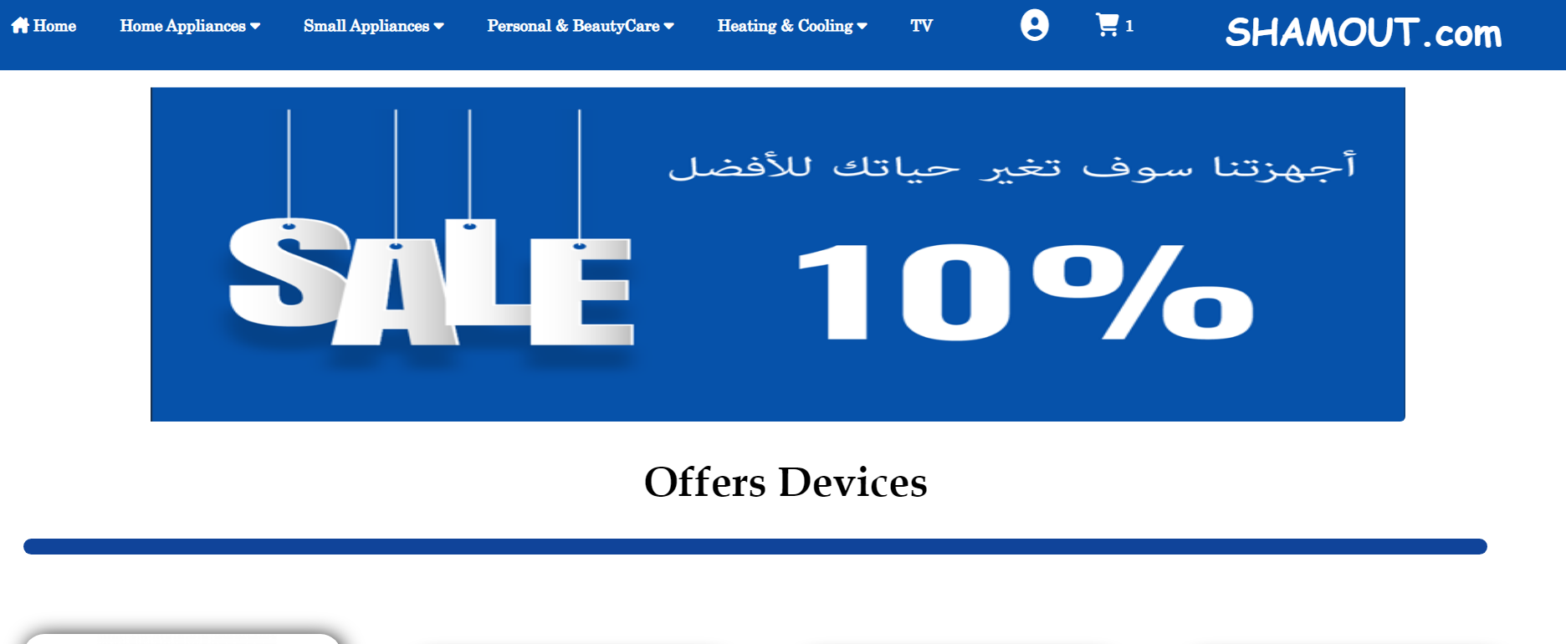

The last section in home page is footer.

This is the footer:



In this section appear the company location ,phone number and email and small description about the company.(this section appears in each pages)

If we click on any social media icon it will go to our website pages ; like intagram and facebook:

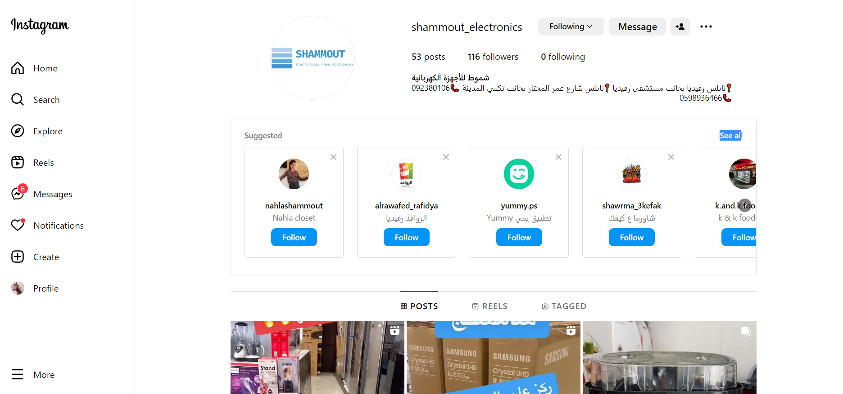

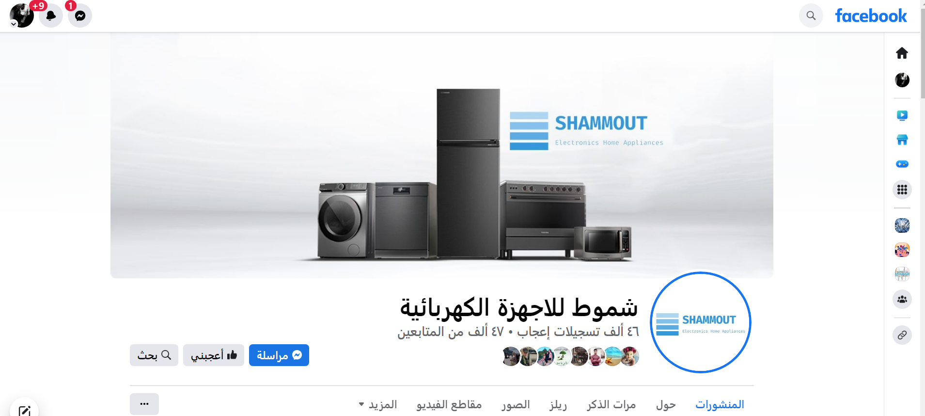

-HOME PAGE if your a admin-

After register and log in as admin , the page open like this .

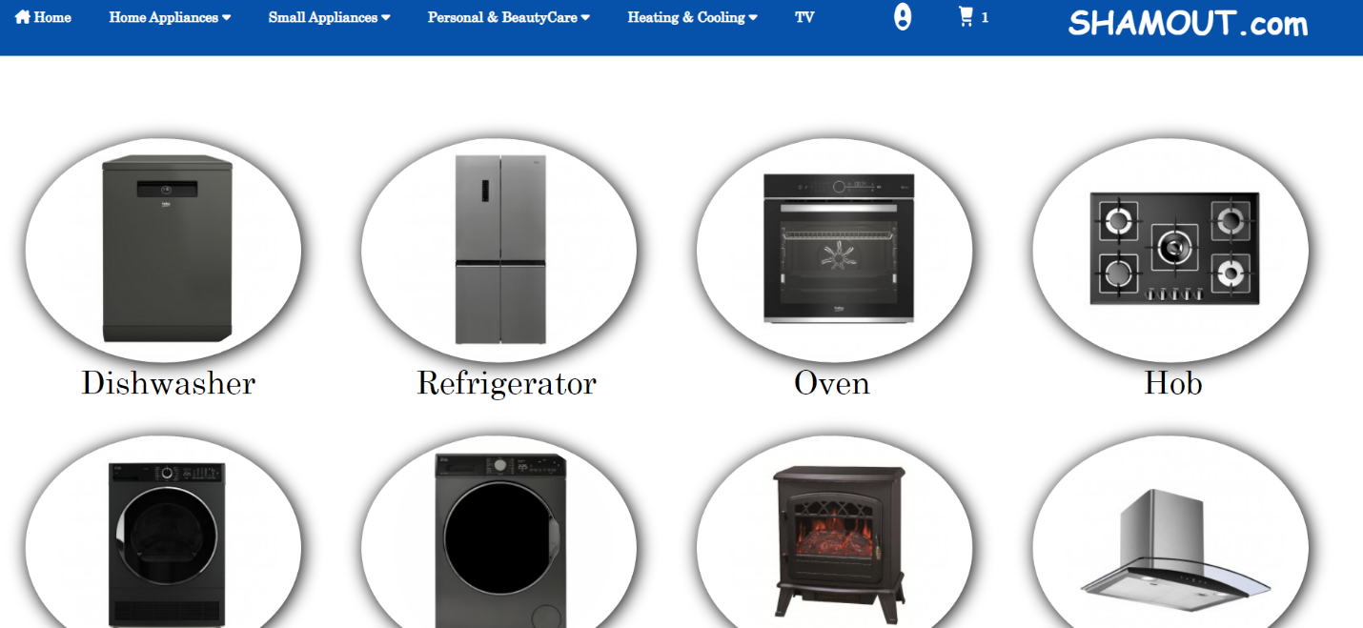

Through this page, the admin can choose the part that he wants to add or modify products for this part(If you place the mouse on the image for product, button will appear(add item), if you click the add item will appear.

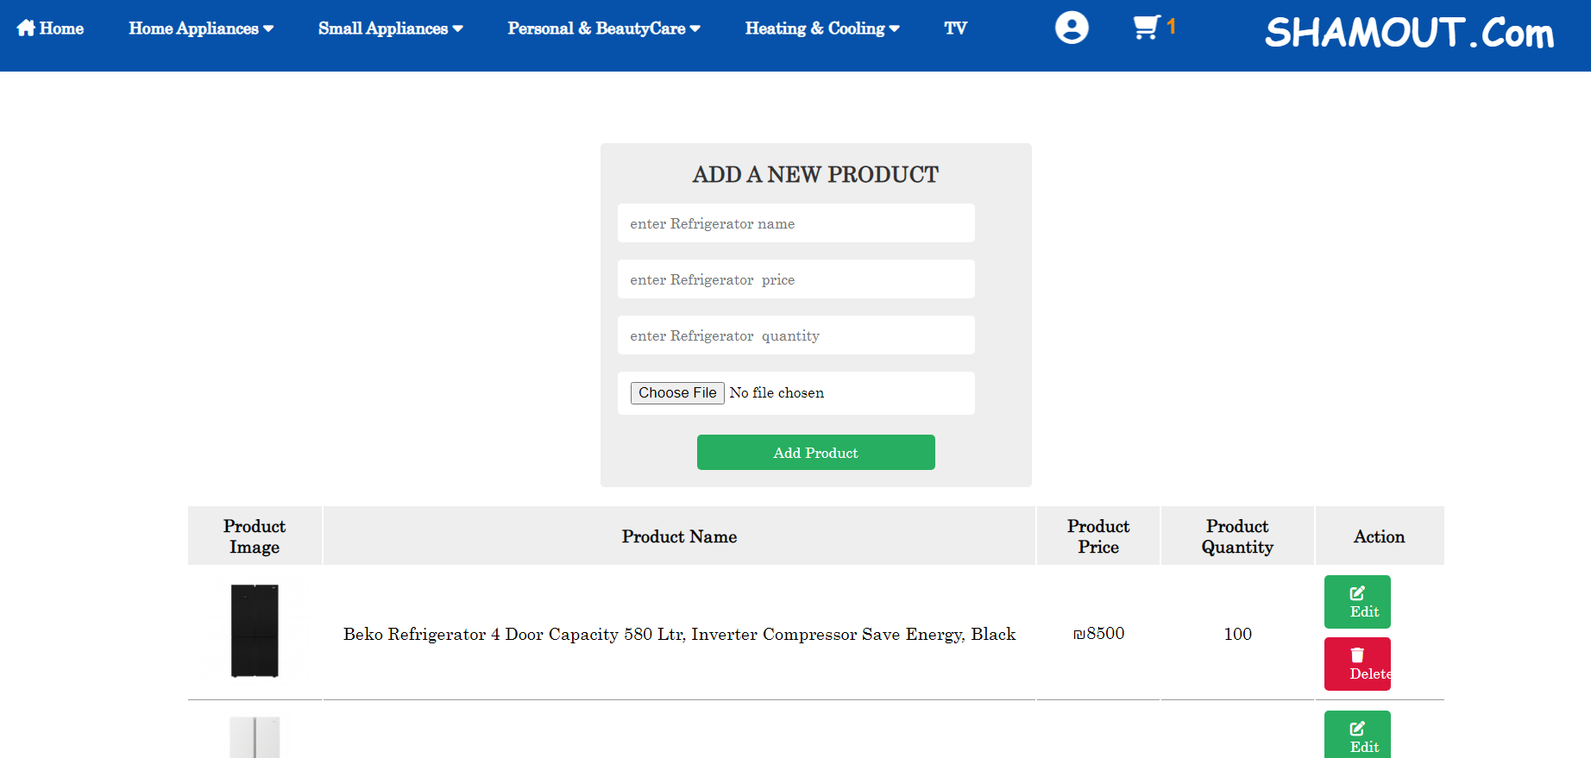

The admin should fill the name (description ),price,quantity and image for product and can be edit or delet for each product added and store each information in database.

*Note: for each product type can add items like this .

When click botten this page apper as:

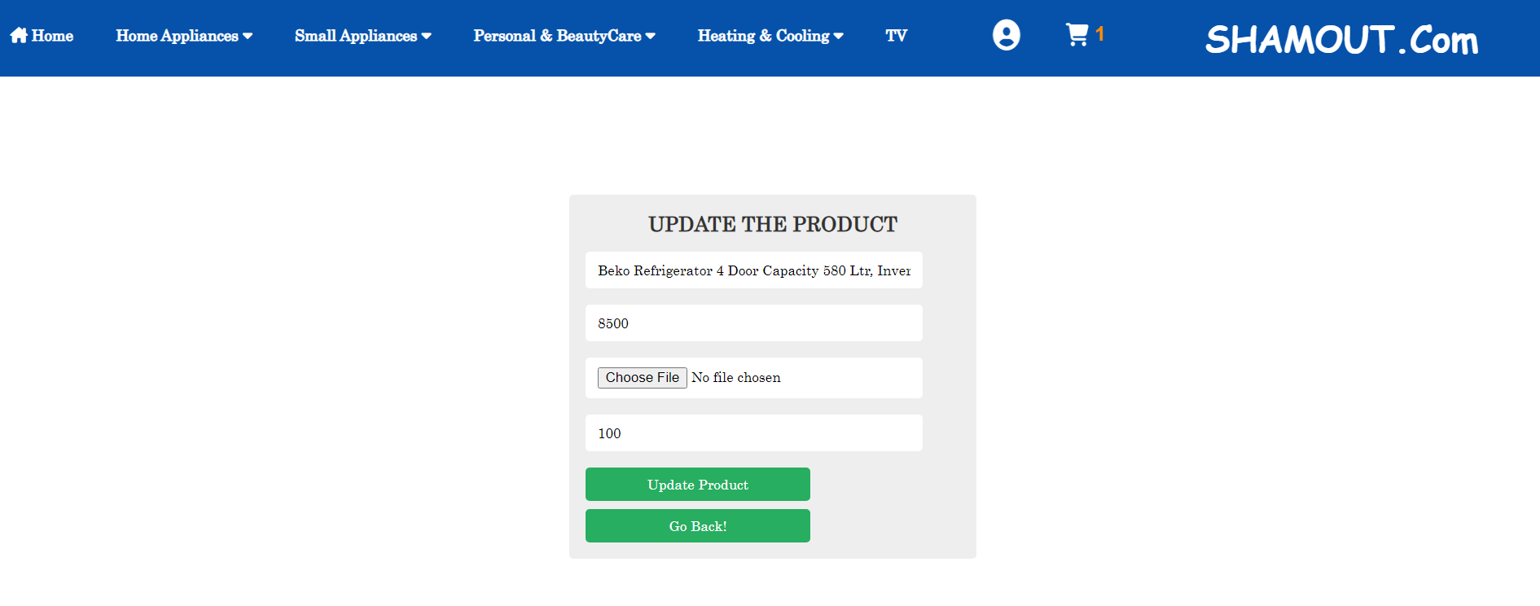

The admin can edit name ,price ,image and quantity then click update product to update in table and in database and return to add item page.

1-Home Appliance:

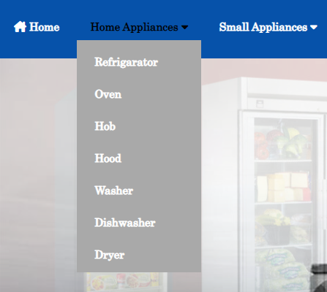

* Refrigerators:

In this website we show our Refrigerators in all brand:

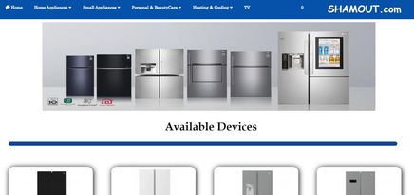

And if we scroll down:

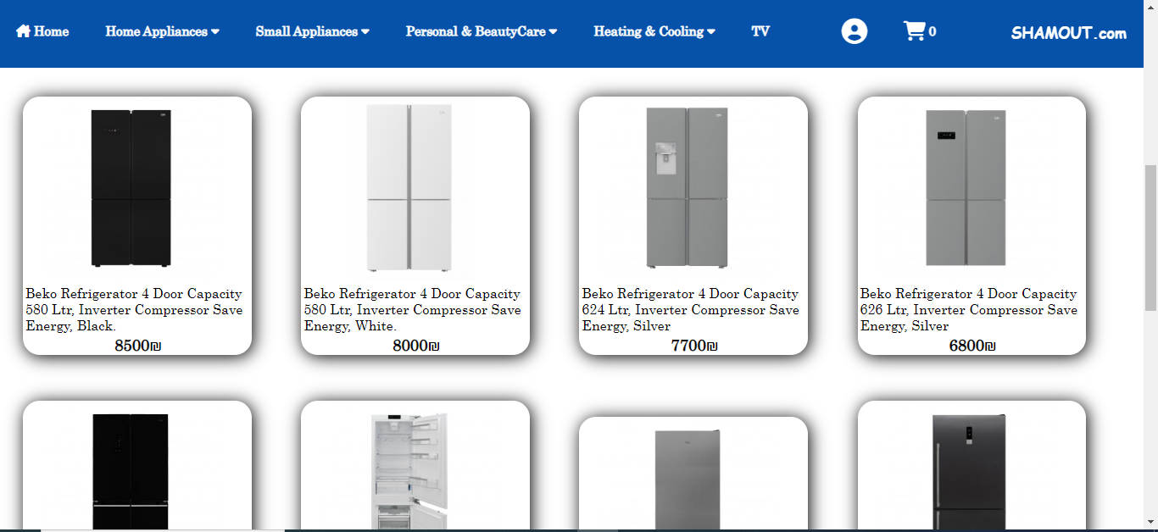

When mouse over on image in card:

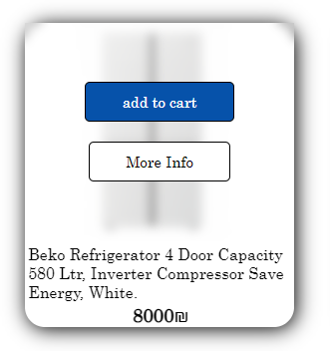

When click on add to cart Button if the item doesn’t already found in shopping cart this item will added to the shopping cart and show a message:

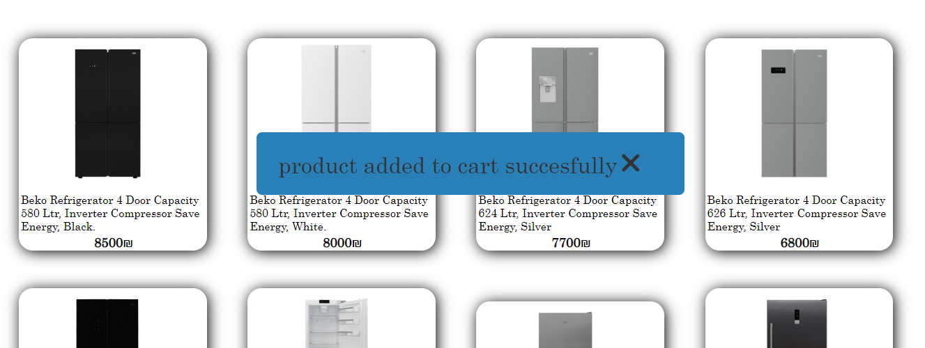

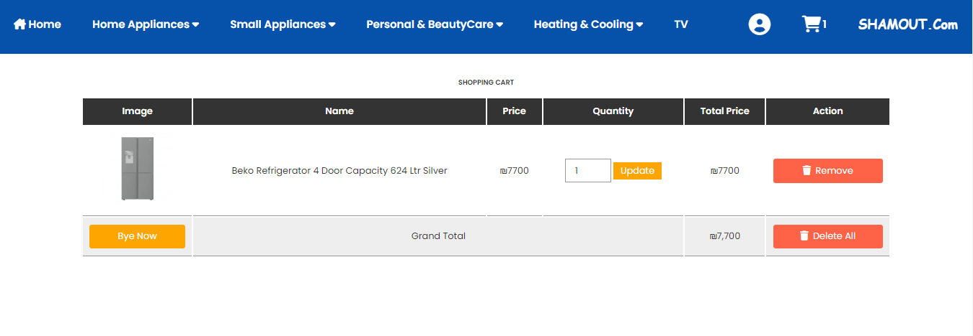

But if the item is already found in shopping cart then will show a message that the item is already found in the shopping cart. But if user want to increase the amount of item he can increase the quantity in shopping cart.

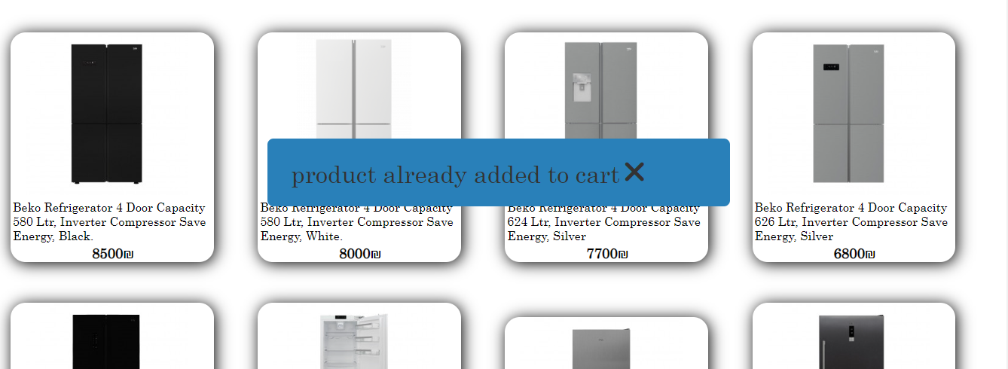

And when click on more information will go to the item page, this page has more details about the item and also when click on add to cart Button this item will added to the shopping cart.

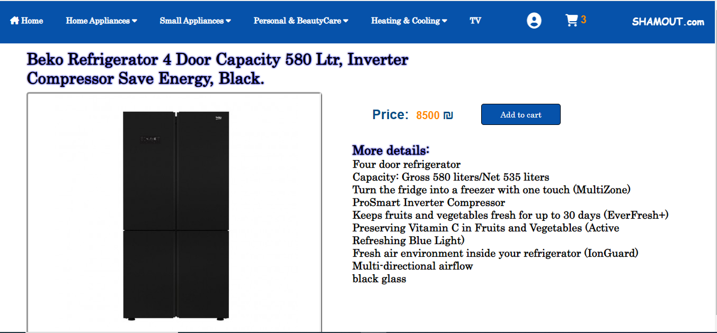

* Oven:

In this website we show our Oven in all brand:

* 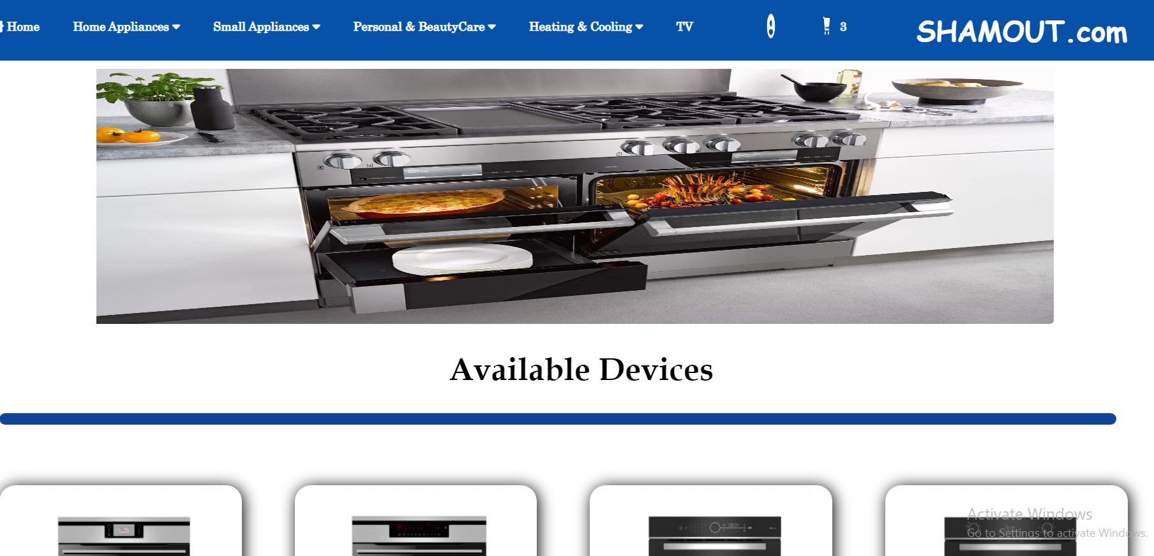
* And if we scroll down:

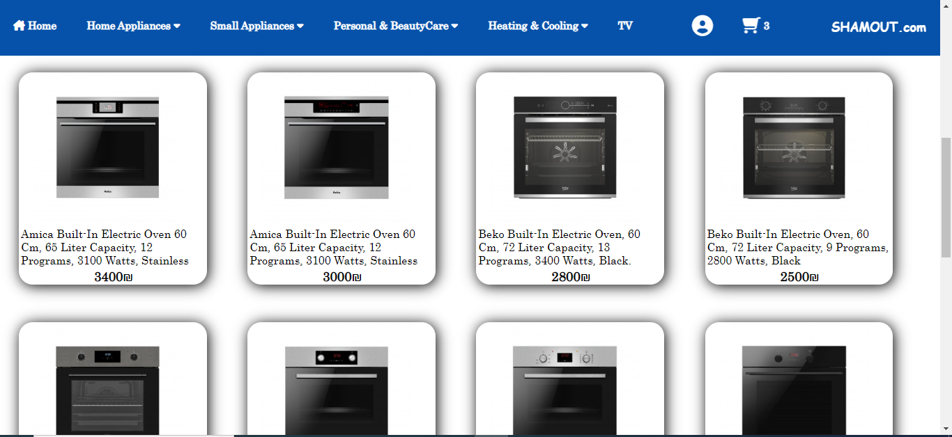

When mouse over on image in card:

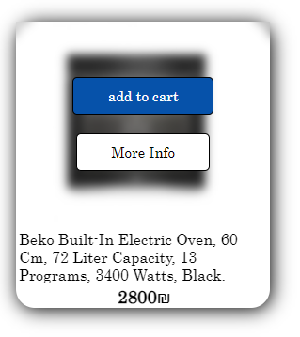

When click on add to cart Button if the item doesn’t already found in shopping cart this item will added to the shopping cart and show a message.

But if the item is already found in shopping cart then will show a message that the item is already found in the shopping cart. But if user want to increase the amount of item he can increase the quantity in shopping cart.

And when click on more information will go to the item page, this page has more details about the item and also when click on add to cart Button this item will added to the shopping cart.

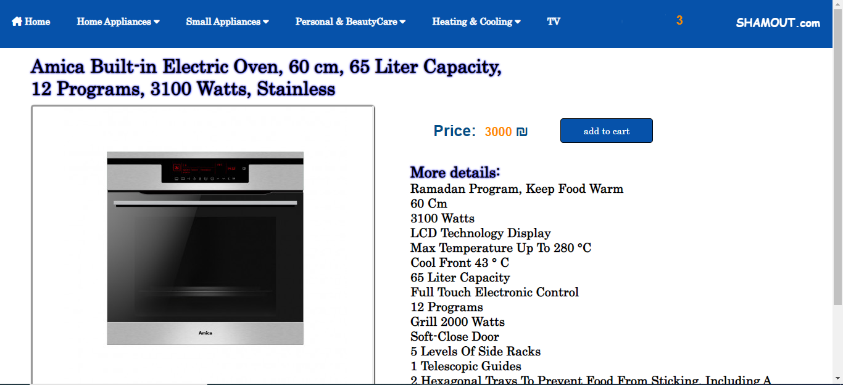

* Hob:

In this website we show our Hob in all brand:

* 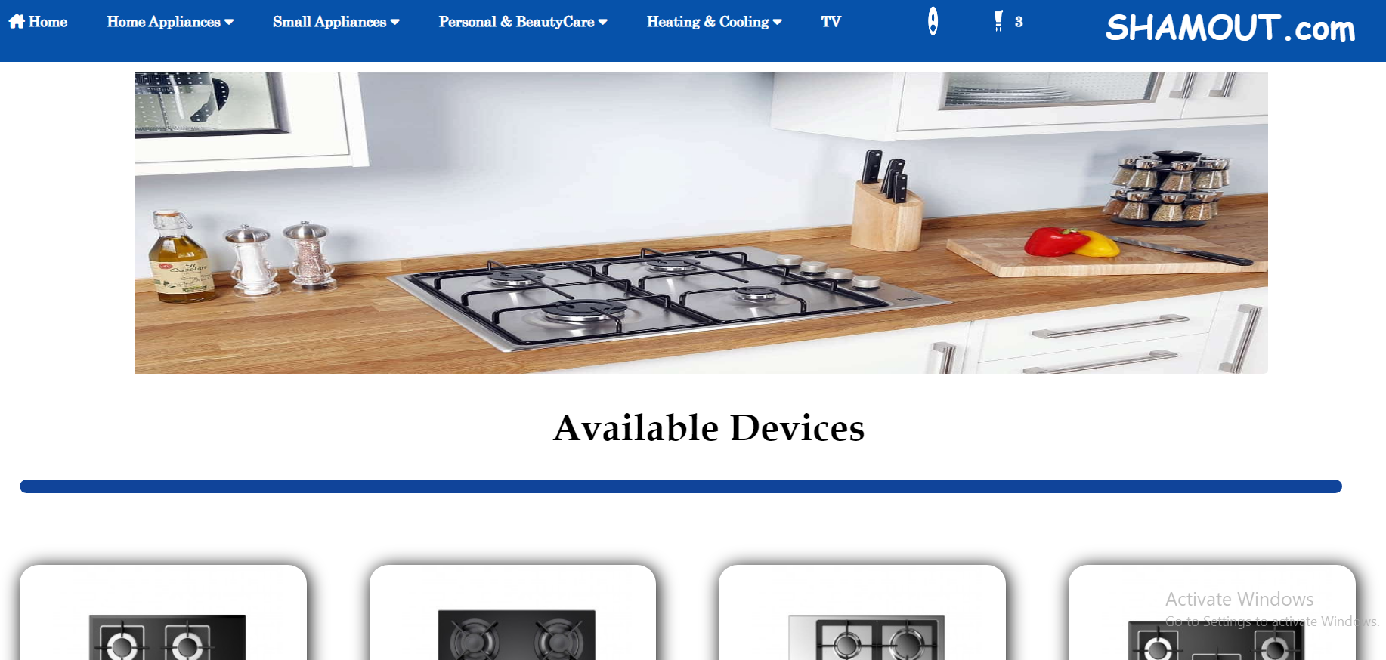

And if we scroll down:

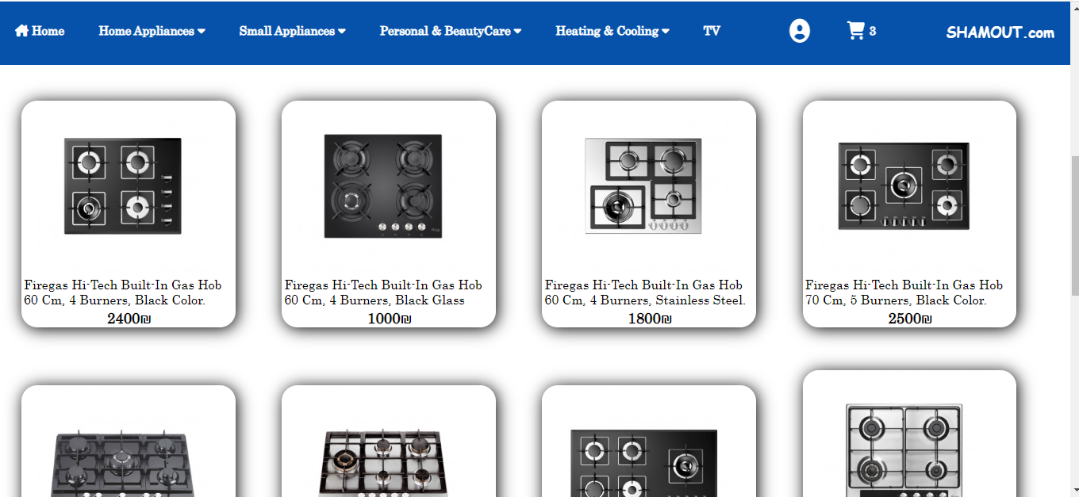

When mouse over on image in card:

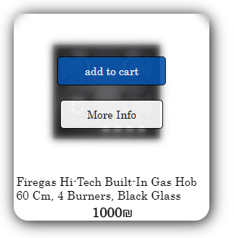

When click on add to cart Button if the item doesn’t already found in shopping cart this item will added to the shopping cart and show a message.

But if the item is already found in shopping cart then will show a message that the item is already found in the shopping cart. But if user want to increase the amount of item he can increase the quantity in shopping cart.

And when click on more information will go to the item page, this page has more details about the item and also when click on add to cart Button this item will added to the shopping cart.

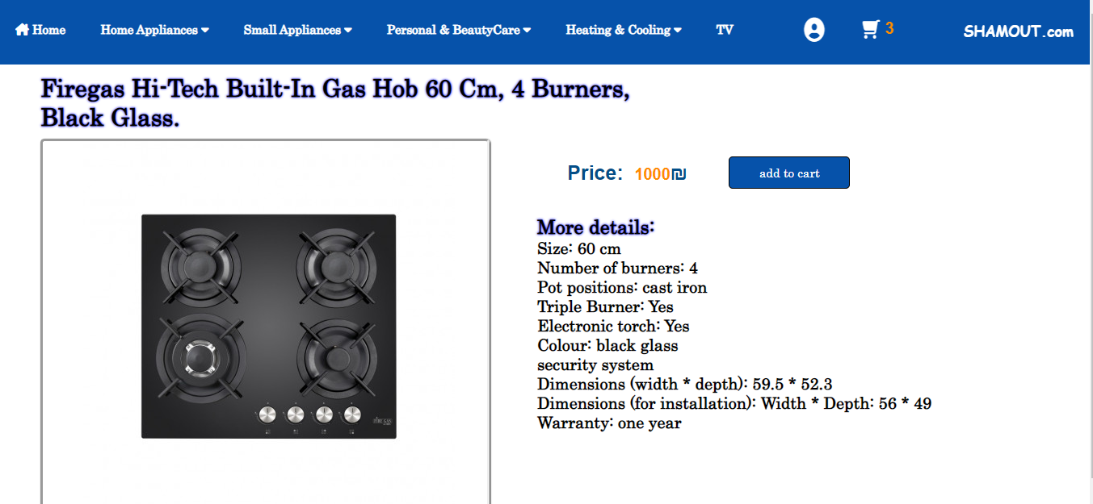

* Hood:

In this website we show our Hood in all brand:

* 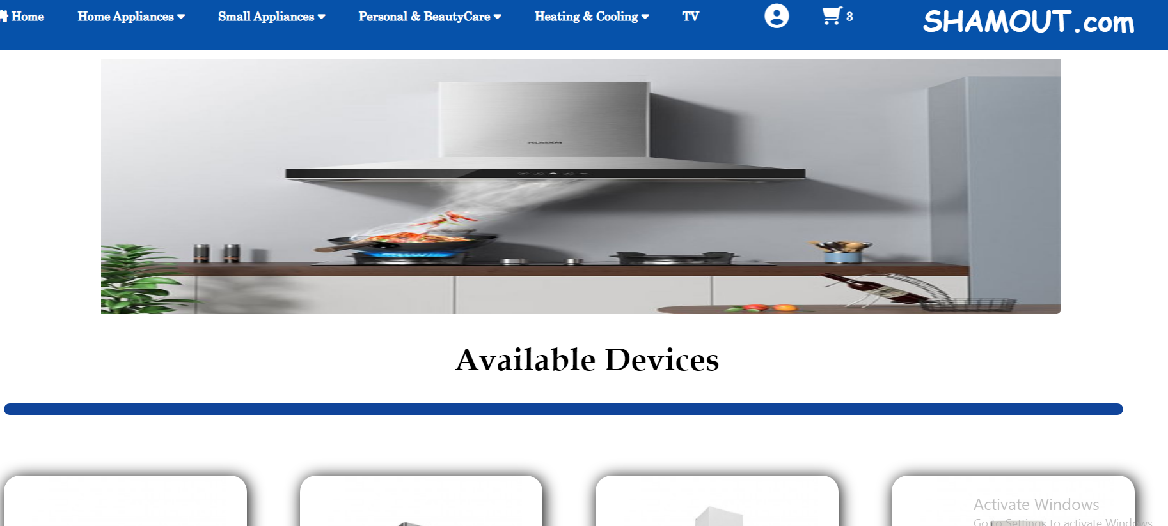

And if we scroll down:

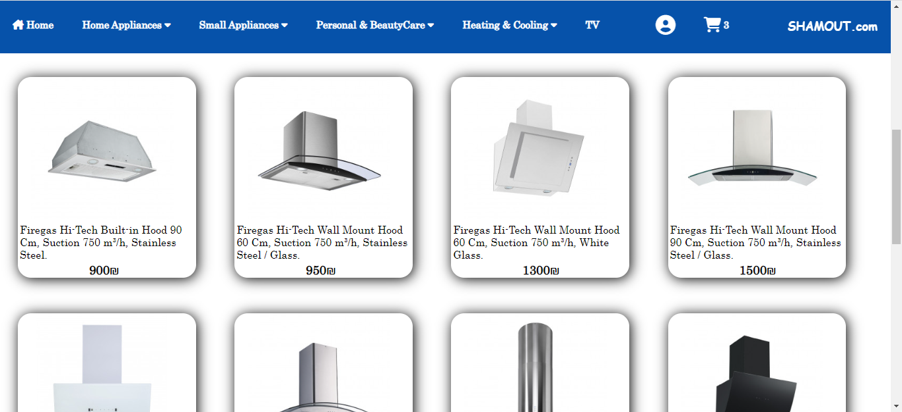

When mouse over on image in card:

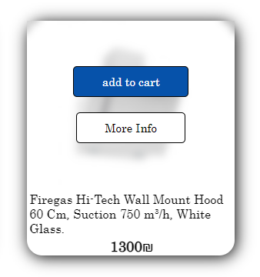

When click on add to cart Button if the item doesn’t already found in shopping cart this item will added to the shopping cart and show a message.

But if the item is already found in shopping cart then will show a message that the item is already found in the shopping cart. But if user want to increase the amount of item he can increase the quantity in shopping cart.

And when click on more information will go to the item page, this page has more details about the item and also when click on add to cart Button this item will added to the shopping cart.

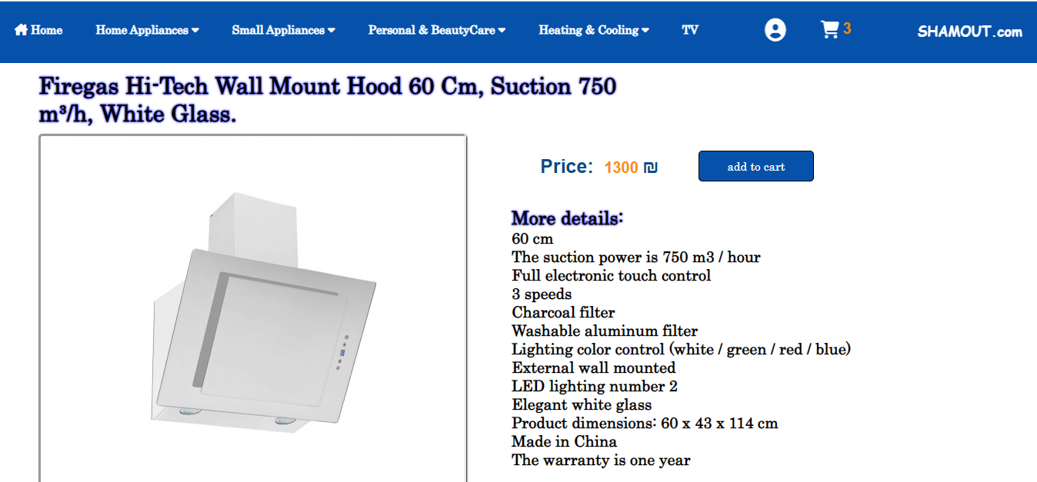

* Washer:

In this website we show our Washer in all brand:

* 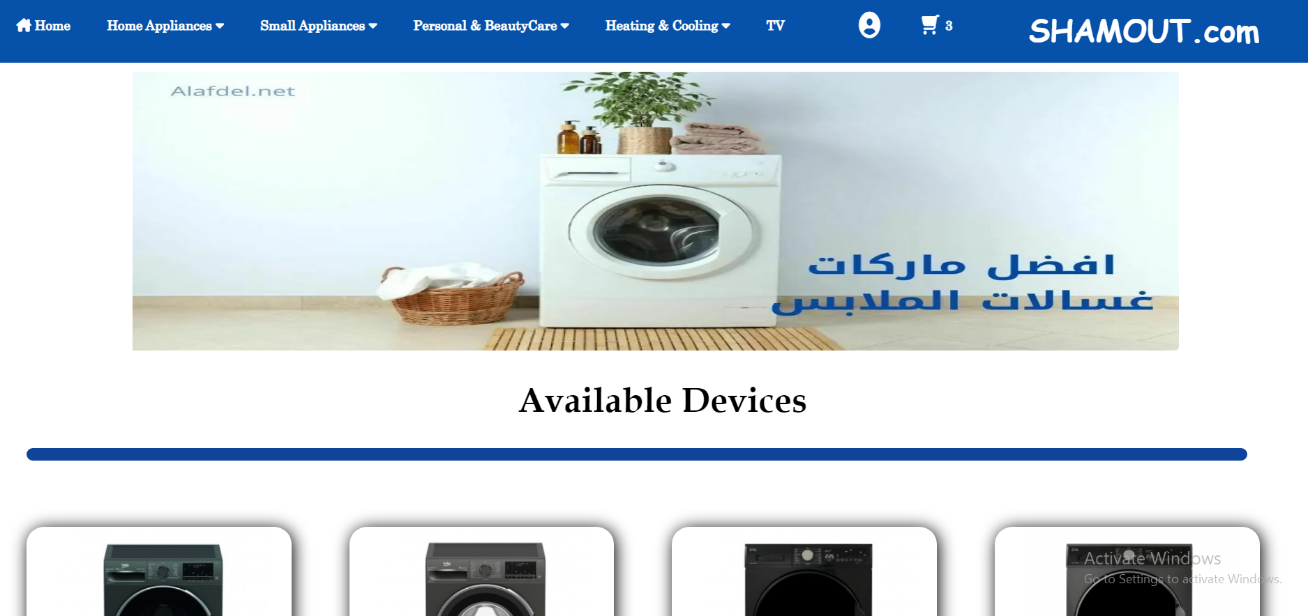

And if we scroll down:

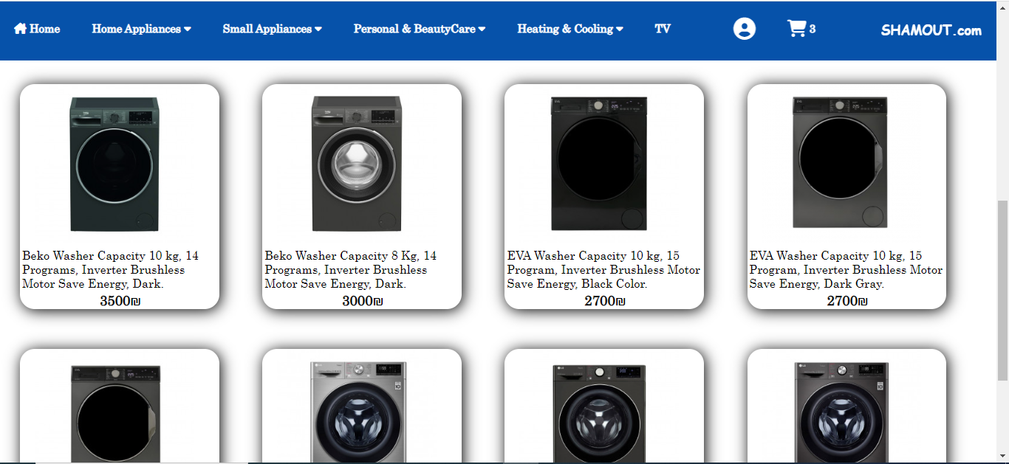

When mouse over on image in card:

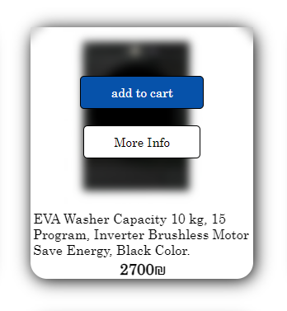

When click on add to cart Button if the item doesn’t already found in shopping cart this item will added to the shopping cart and show a message.

But if the item is already found in shopping cart then will show a message that the item is already found in the shopping cart. But if user want to increase the amount of item he can increase the quantity in shopping cart.

And when click on more information will go to the item page, this page has more details about the item and also when click on add to cart Button this item will added to the shopping cart.

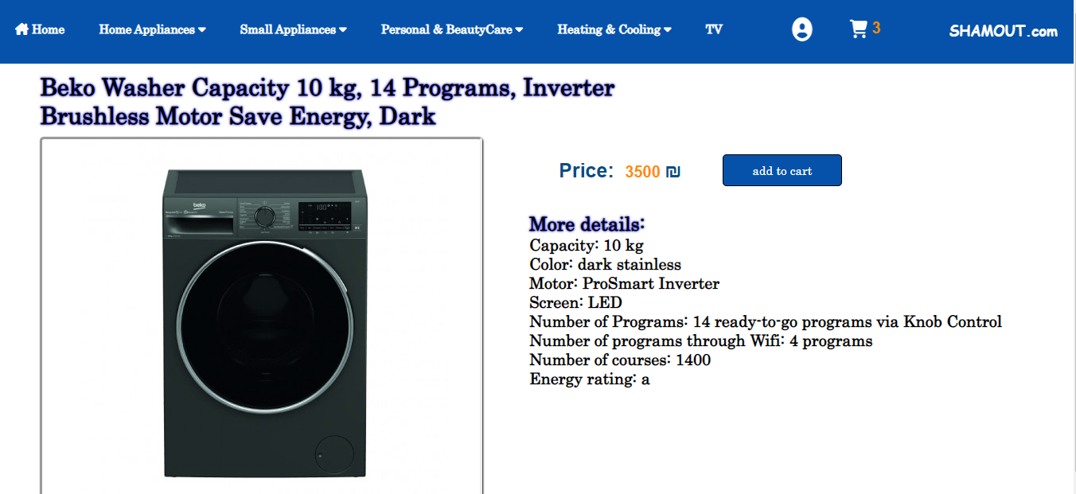

* Dishwasher:

In this website we show our Dishwasher in all brand:

* 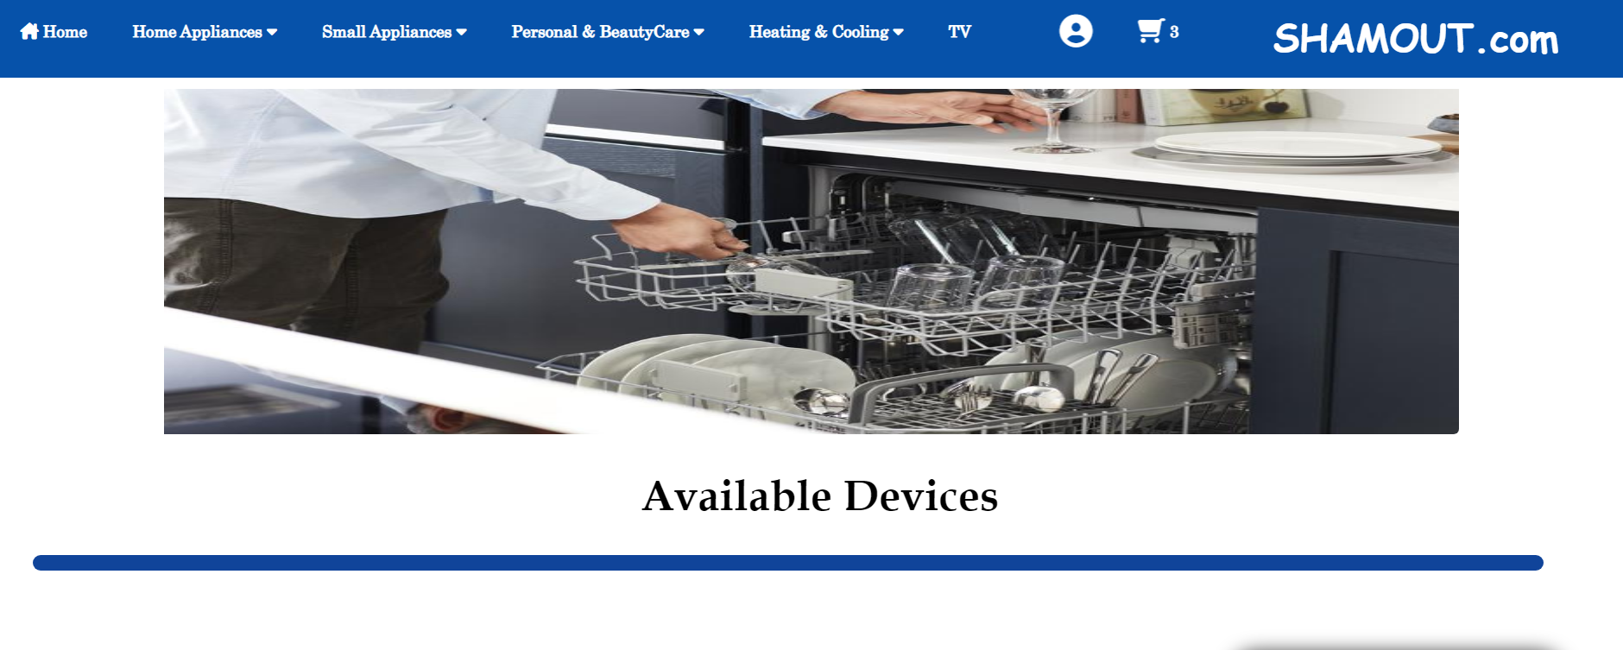

And if we scroll down:

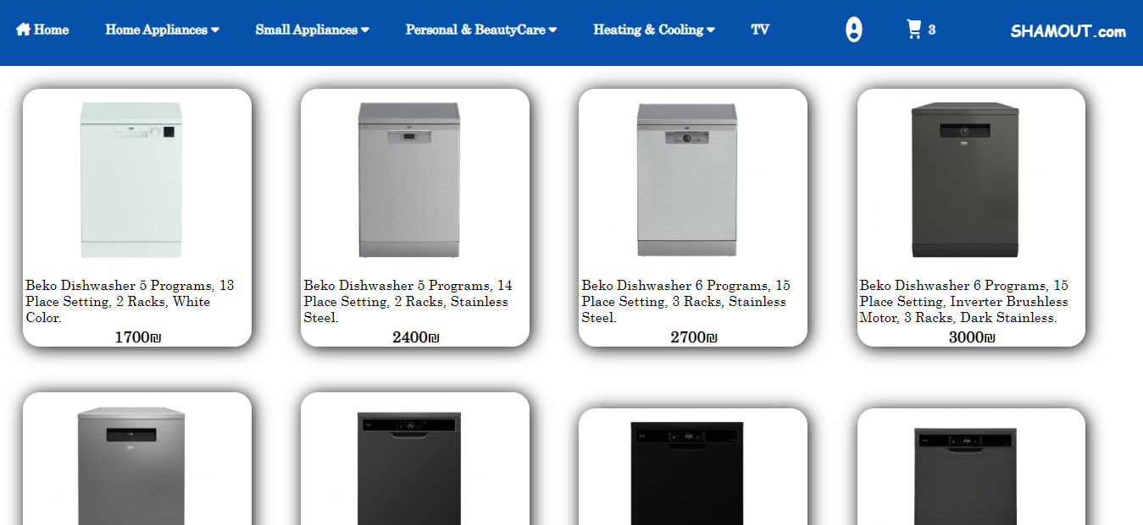

When mouse over on image in card:

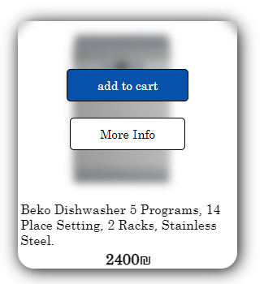

When click on add to cart Button if the item doesn’t already found in shopping cart this item will added to the shopping cart and show a message.

But if the item is already found in shopping cart then will show a message that the item is already found in the shopping cart. But if user want to increase the amount of item he can increase the quantity in shopping cart.

And when click on more information will go to the item page, this page has more details about the item and also when click on add to cart Button this item will added to the shopping cart.

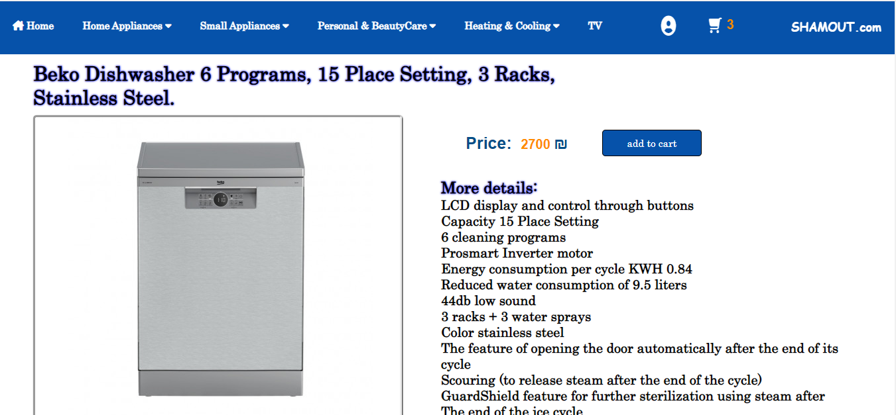

* Dryer:

In this website we show our Dryer in all brand:

* 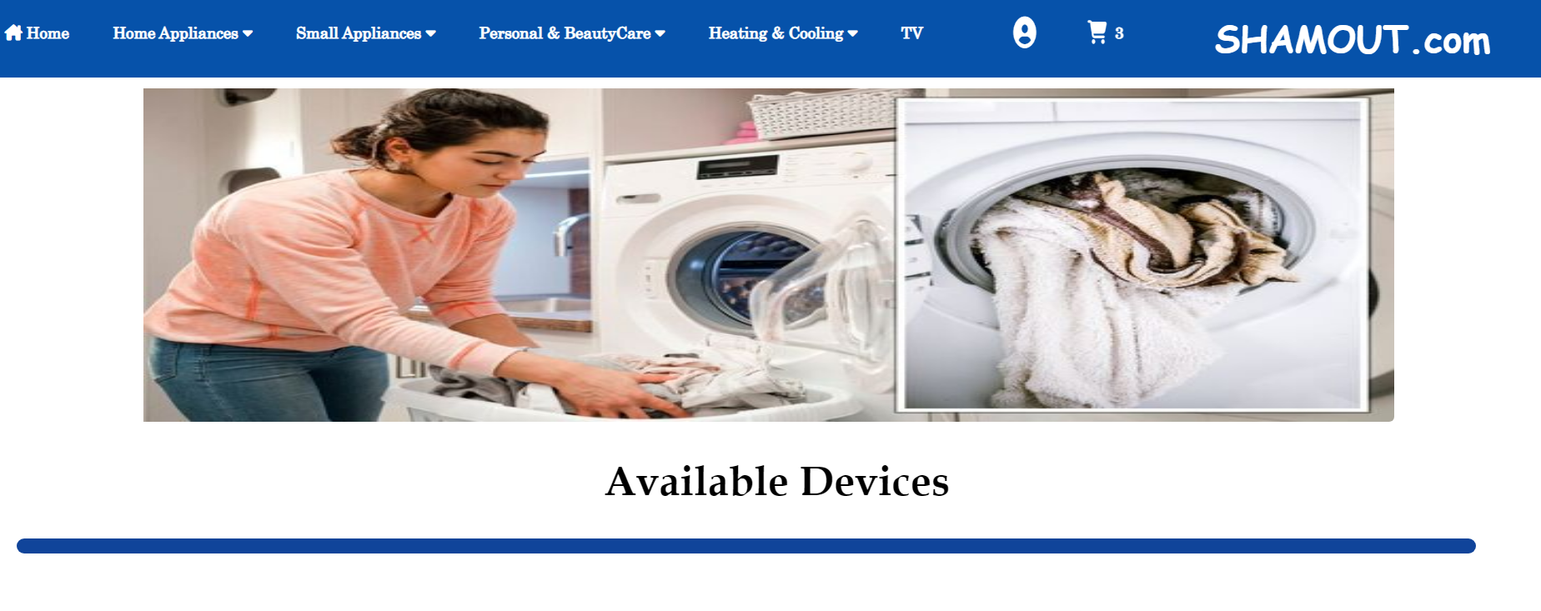

And if we scroll down:

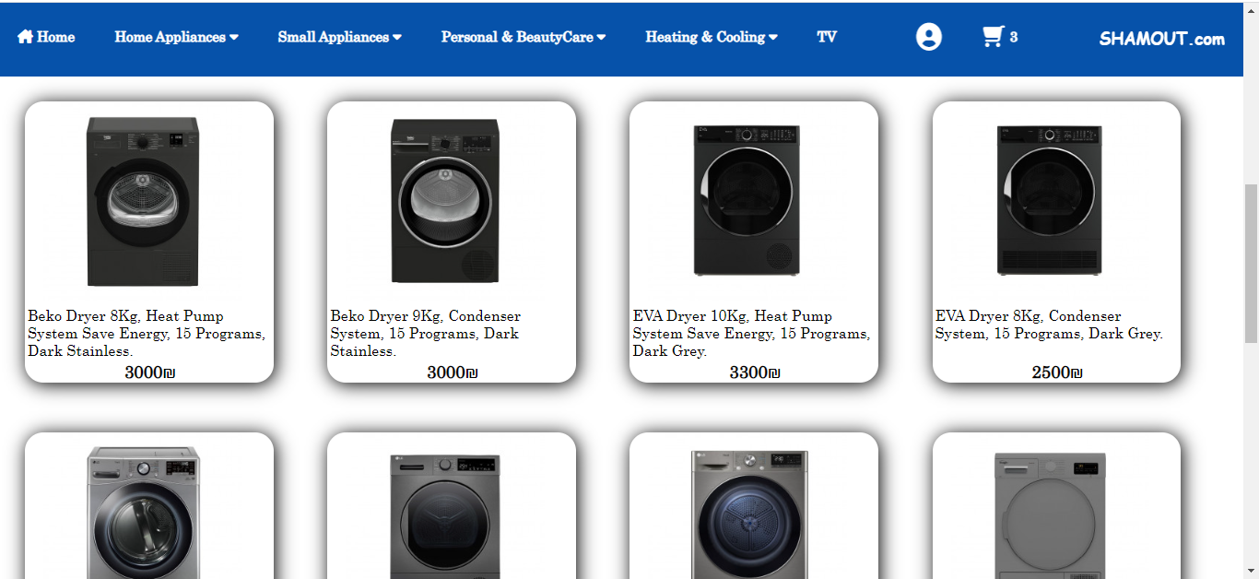

When mouse over on image in card:

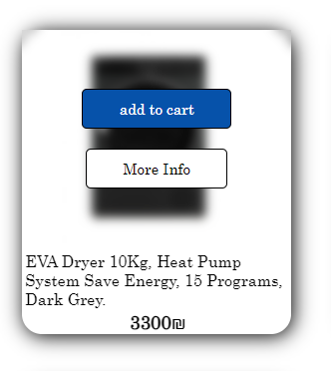

When click on add to cart Button if the item doesn’t already found in shopping cart this item will added to the shopping cart and show a message.

But if the item is already found in shopping cart then will show a message that the item is already found in the shopping cart. But if user want to increase the amount of item he can increase the quantity in shopping cart.

And when click on more information will go to the item page, this page has more details about the item and also when click on add to cart Button this item will added to the shopping cart.

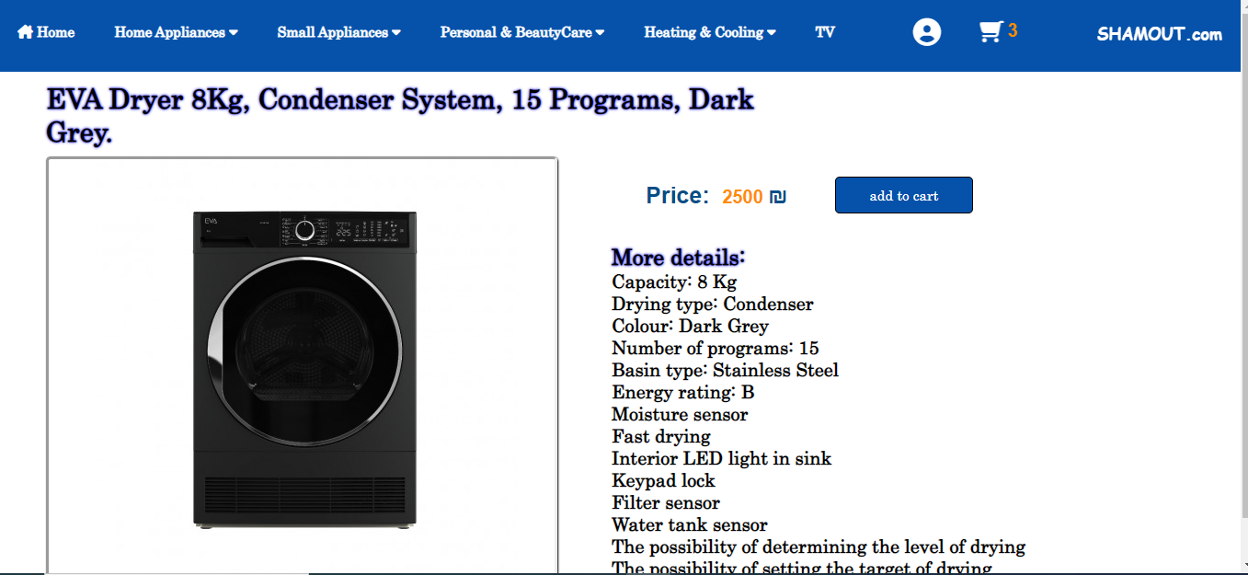

2-Small Appliance:

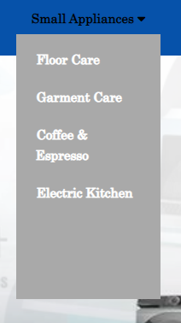

* Floor Care:

In this website we show our Floor Care in all brand:

* 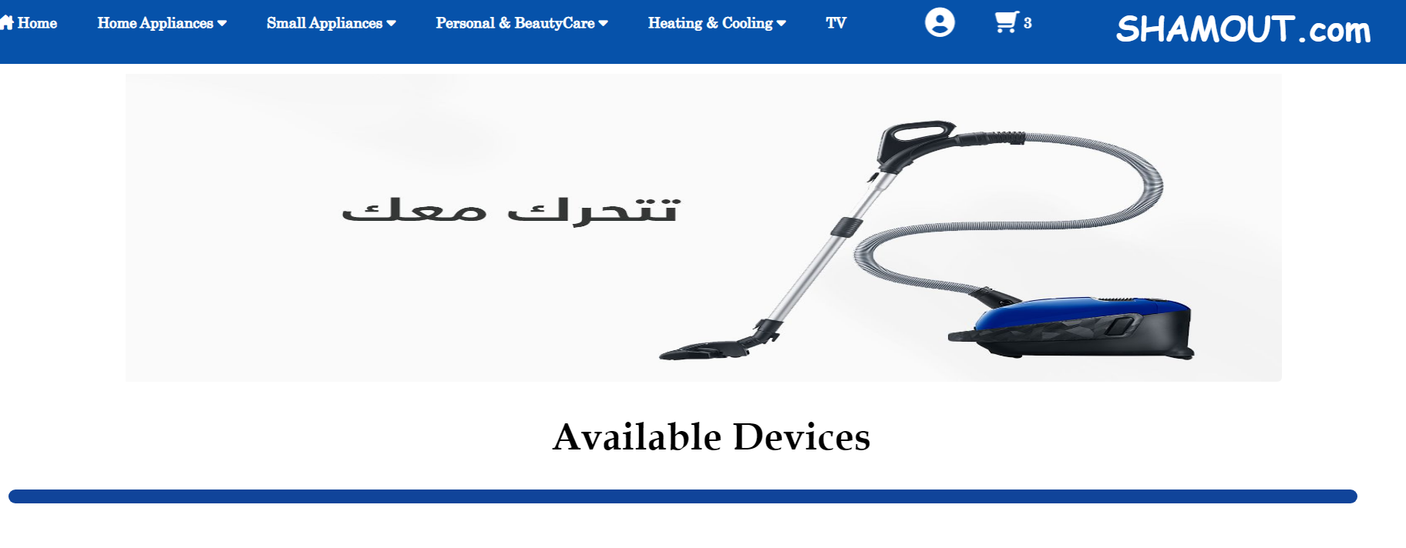

And if we scroll down:

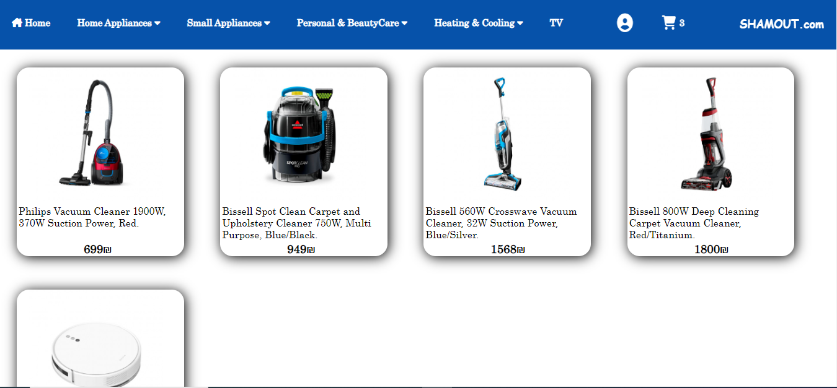

When mouse over on image in card:

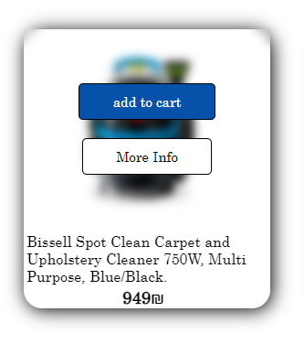

When click on add to cart Button if the item doesn’t already found in shopping cart this item will added to the shopping cart and show a message.

But if the item is already found in shopping cart then will show a message that the item is already found in the shopping cart. But if user want to increase the amount of item he can increase the quantity in shopping cart.

And when click on more information will go to the item page, this page has more details about the item and also when click on add to cart Button this item will added to the shopping cart.

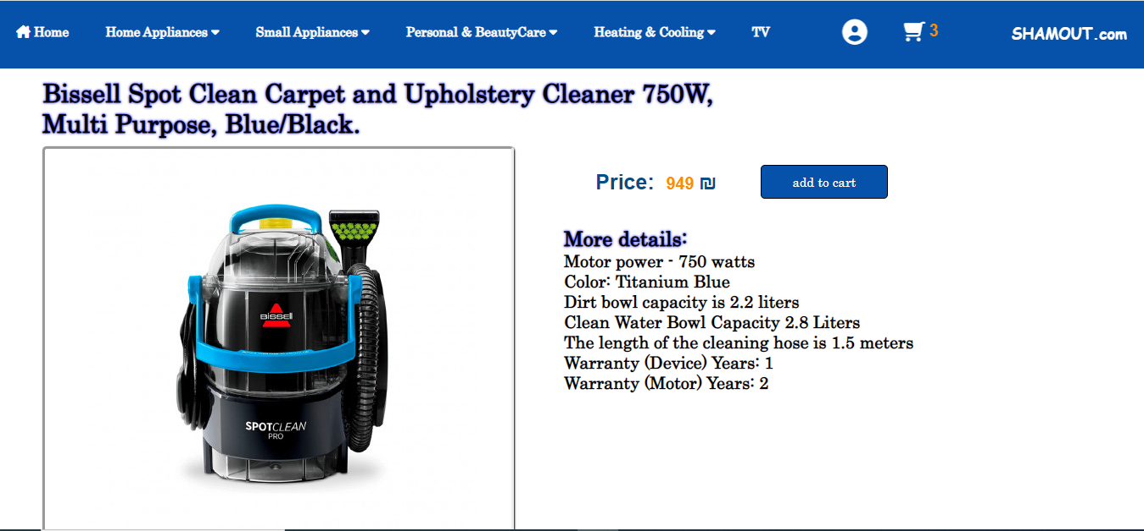

* Iron:

In this website we show our Iron in all brand:

* 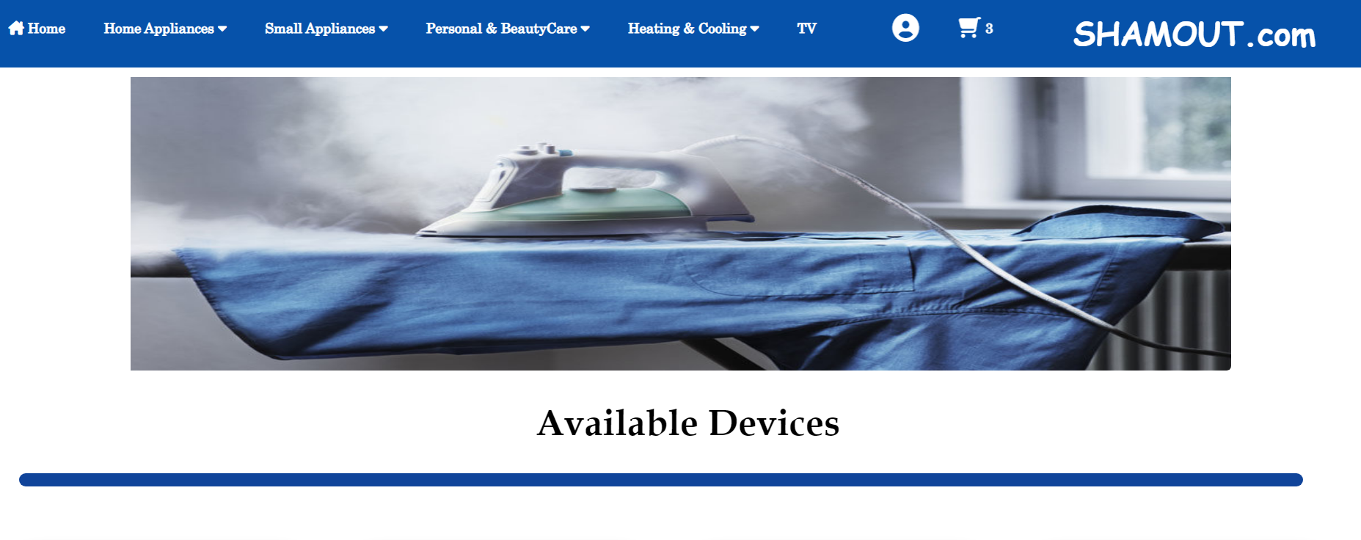

And if we scroll down:

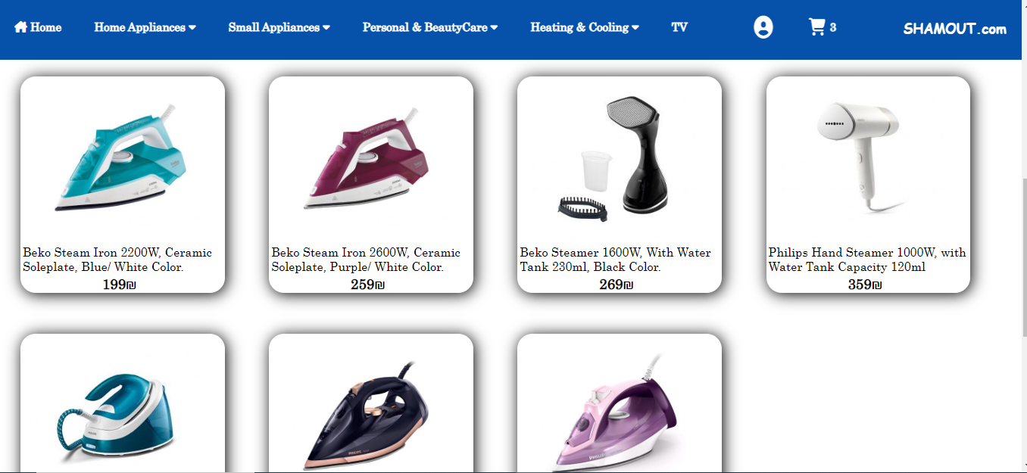

When mouse over on image in card:

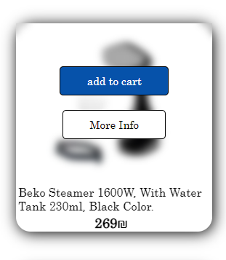

When click on add to cart Button if the item doesn’t already found in shopping cart this item will added to the shopping cart and show a message.

But if the item is already found in shopping cart then will show a message that the item is already found in the shopping cart. But if user want to increase the amount of item he can increase the quantity in shopping cart.

And when click on more information will go to the item page, this page has more details about the item and also when click on add to cart Button this item will added to the shopping cart.

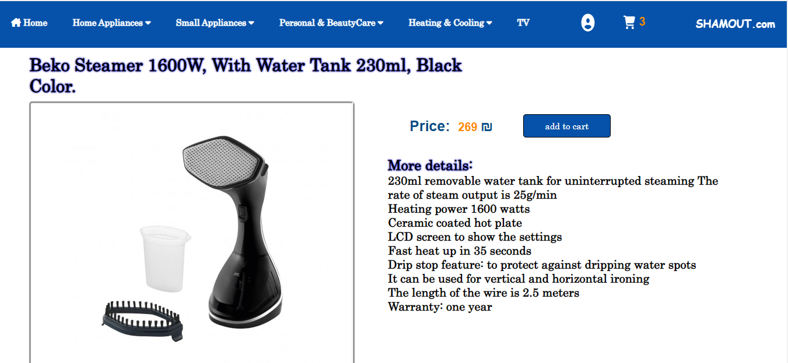

* Coffee & Espresso:

In this website we show our Coffee & Espresso machine in all brand:

* 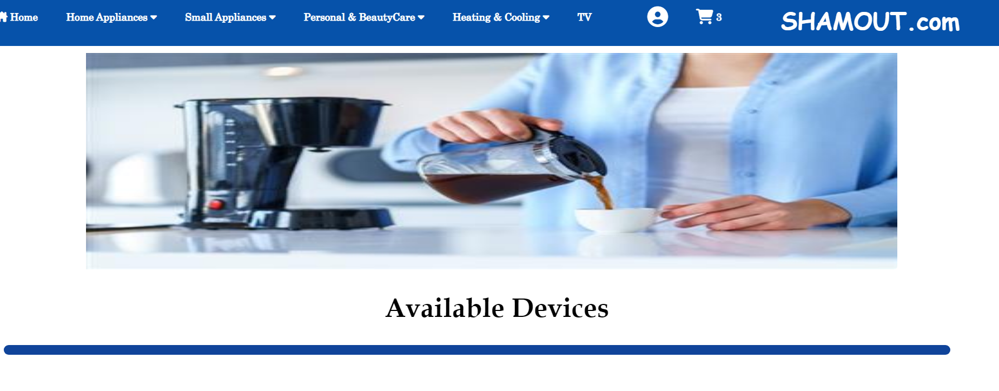

And if we scroll down:

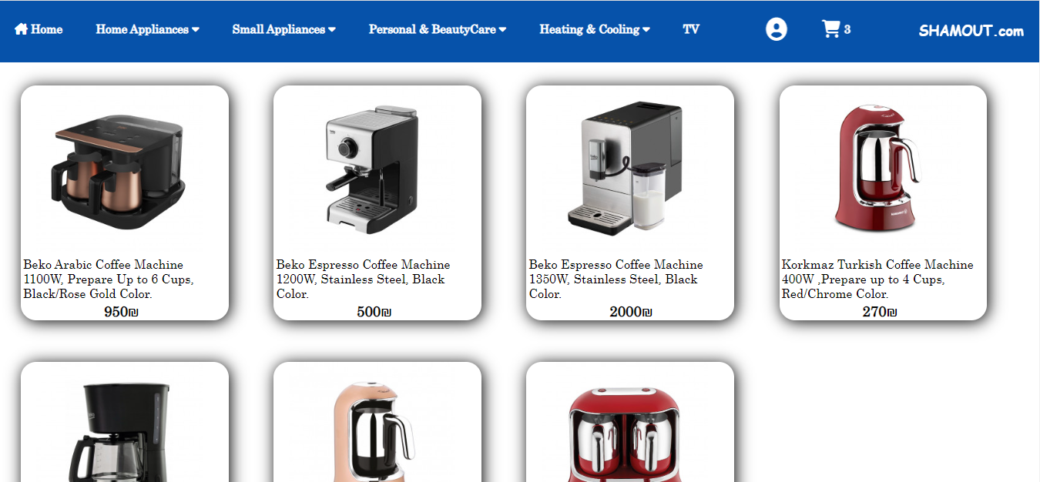

When mouse over on image in card:

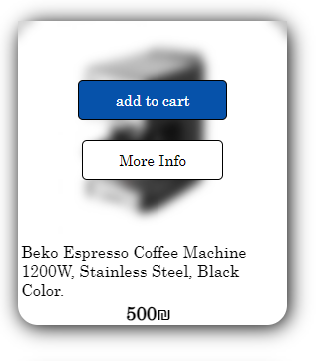

When click on add to cart Button if the item doesn’t already found in shopping cart this item will added to the shopping cart and show a message.

But if the item is already found in shopping cart then will show a message that the item is already found in the shopping cart. But if user want to increase the amount of item he can increase the quantity in shopping cart.

And when click on more information will go to the item page, this page has more details about the item and also when click on add to cart Button this item will added to the shopping cart.

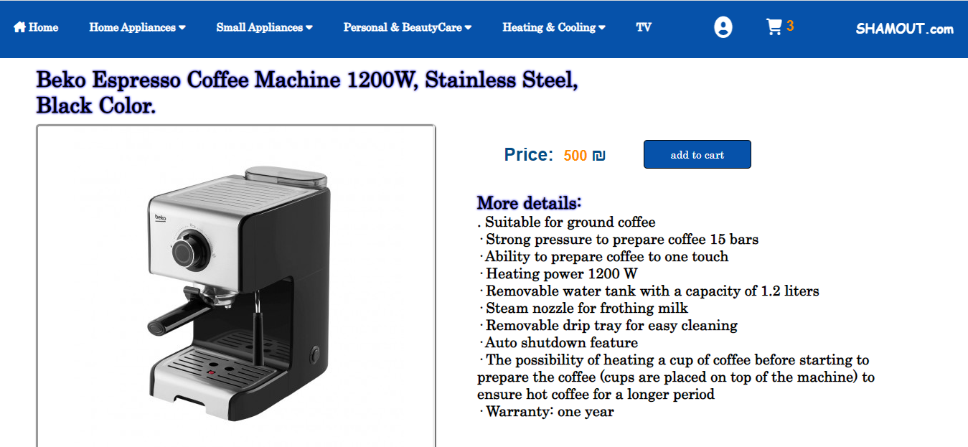

* Small Appliance:

In this website we show our food processor, fruit and vegetable juicer, vegetable chopper, Microwave, Toaster Pressure, hand mixer, stand mixer and electric kettle in all brand:

* 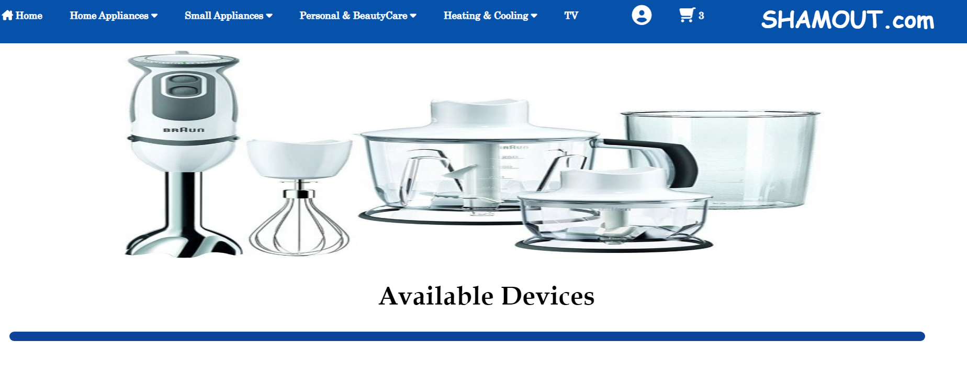

And if we scroll down:

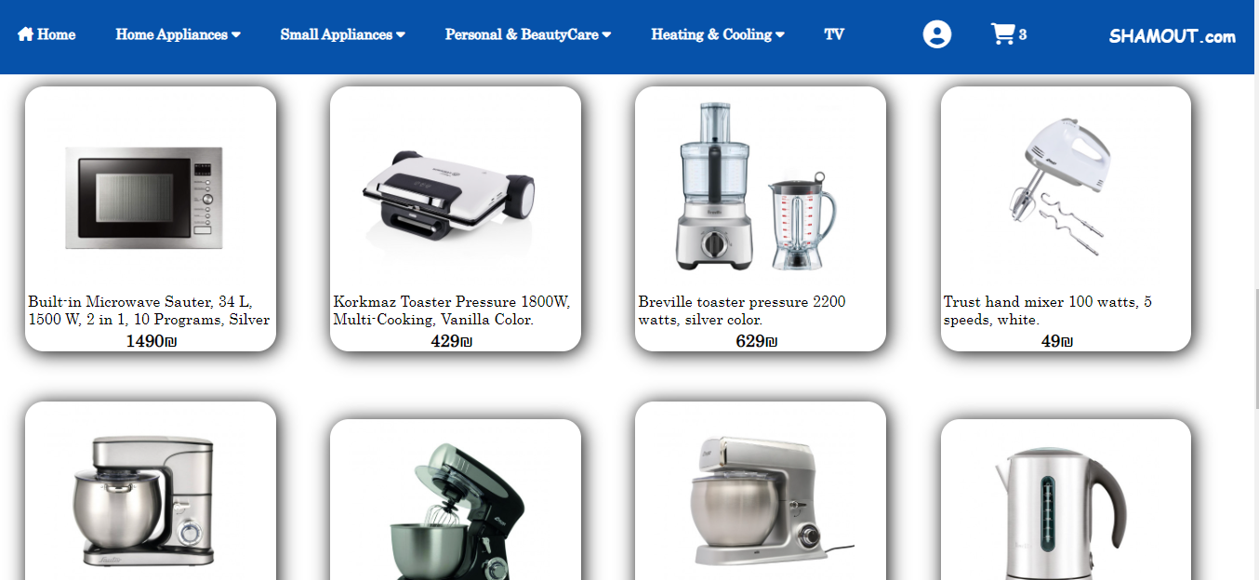

When mouse over on image in card:

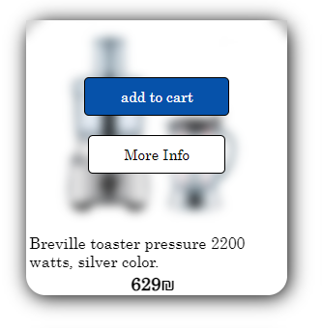

When click on add to cart Button if the item doesn’t already found in shopping cart this item will added to the shopping cart and show a message.

But if the item is already found in shopping cart then will show a message that the item is already found in the shopping cart. But if user want to increase the amount of item he can increase the quantity in shopping cart.

And when click on more information will go to the item page, this page has more details about the item and also when click on add to cart Button this item will added to the shopping cart.

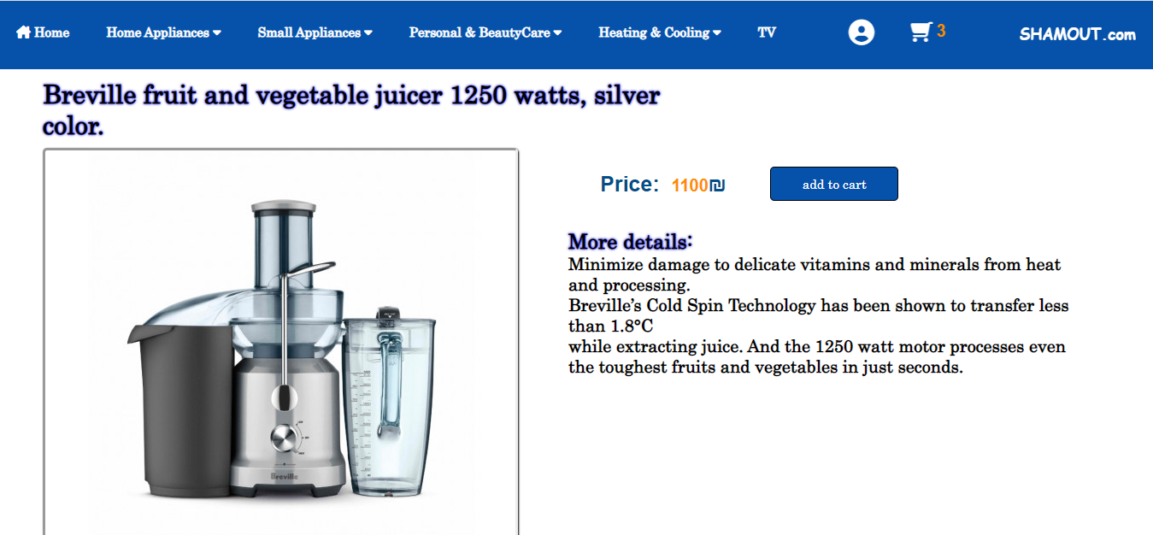

3-Personal & Beauty Care:

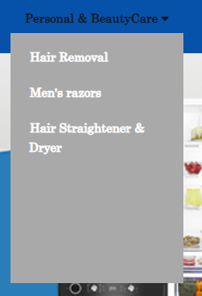

* Hair remover:

In this website we show our Hair remover in all brand:

* 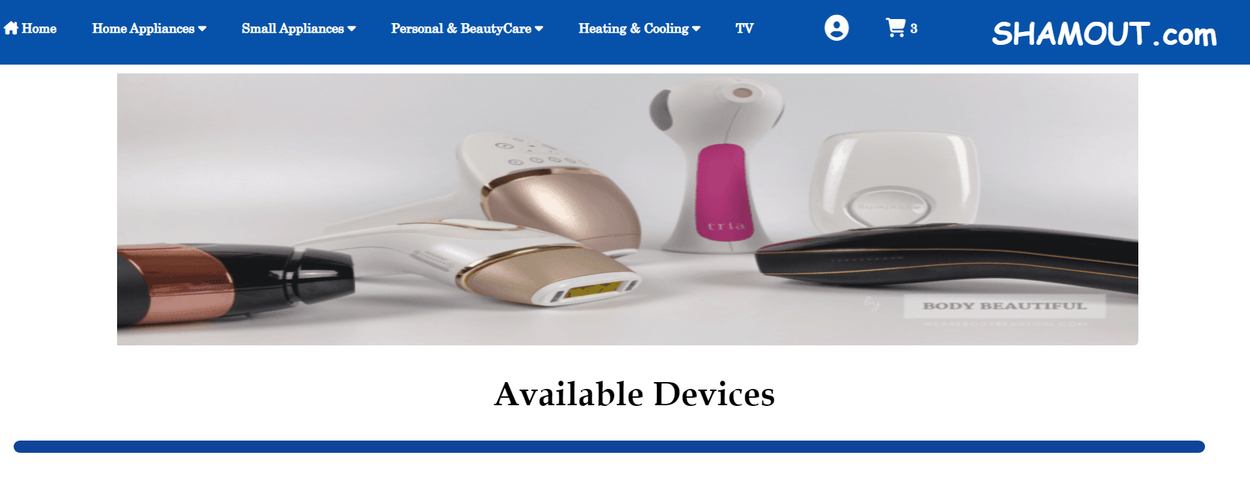

And if we scroll down:

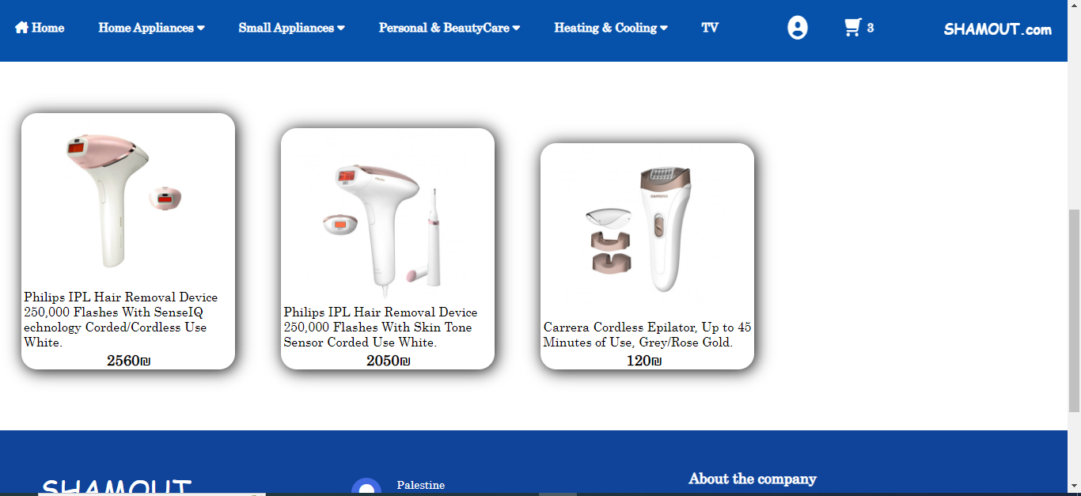

When mouse over on image in card:

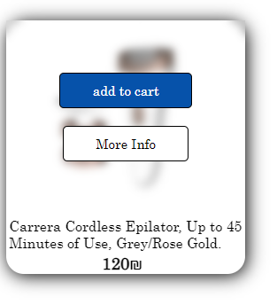

When click on add to cart Button if the item doesn’t already found in shopping cart this item will added to the shopping cart and show a message.

But if the item is already found in shopping cart then will show a message that the item is already found in the shopping cart. But if user want to increase the amount of item he can increase the quantity in shopping cart.

And when click on more information will go to the item page, this page has more details about the item and also when click on add to cart Button this item will added to the shopping cart.

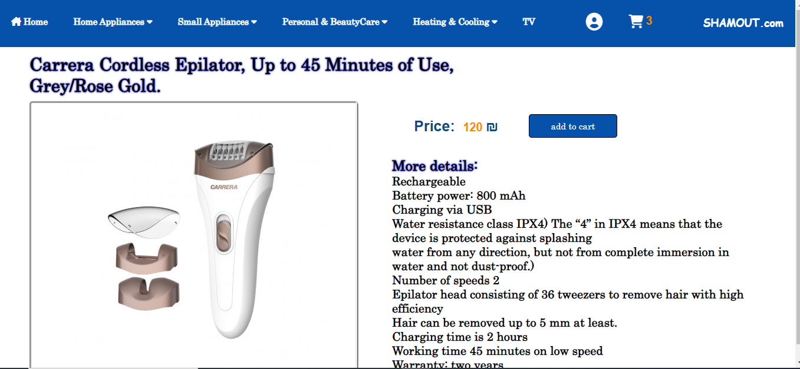

* Hair straightener & Dryer:

In this website we show our Hair straightener & Dryer in all brand:

* 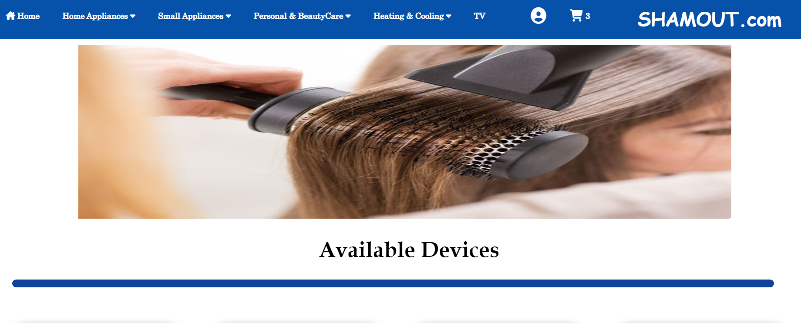

And if we scroll down:

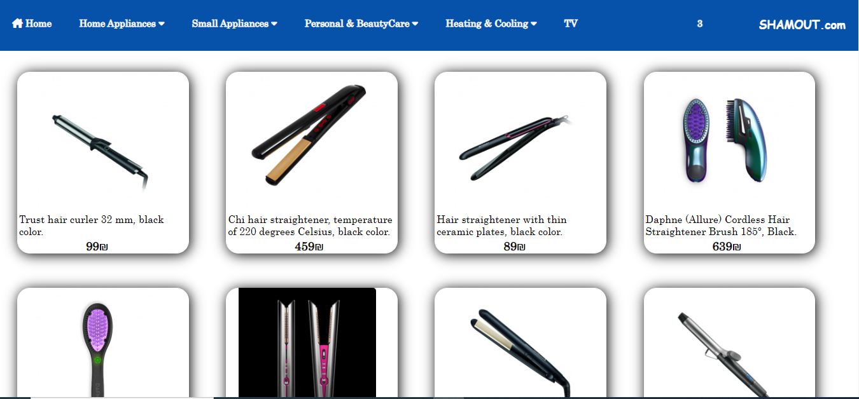

When mouse over on image in card:

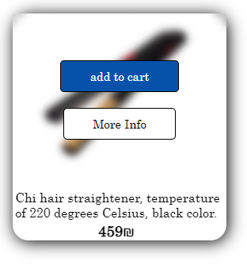

When click on add to cart Button if the item doesn’t already found in shopping cart this item will added to the shopping cart and show a message.

But if the item is already found in shopping cart then will show a message that the item is already found in the shopping cart. But if user want to increase the amount of item he can increase the quantity in shopping cart.

And when click on more information will go to the item page, this page has more details about the item and also when click on add to cart Button this item will added to the shopping cart.

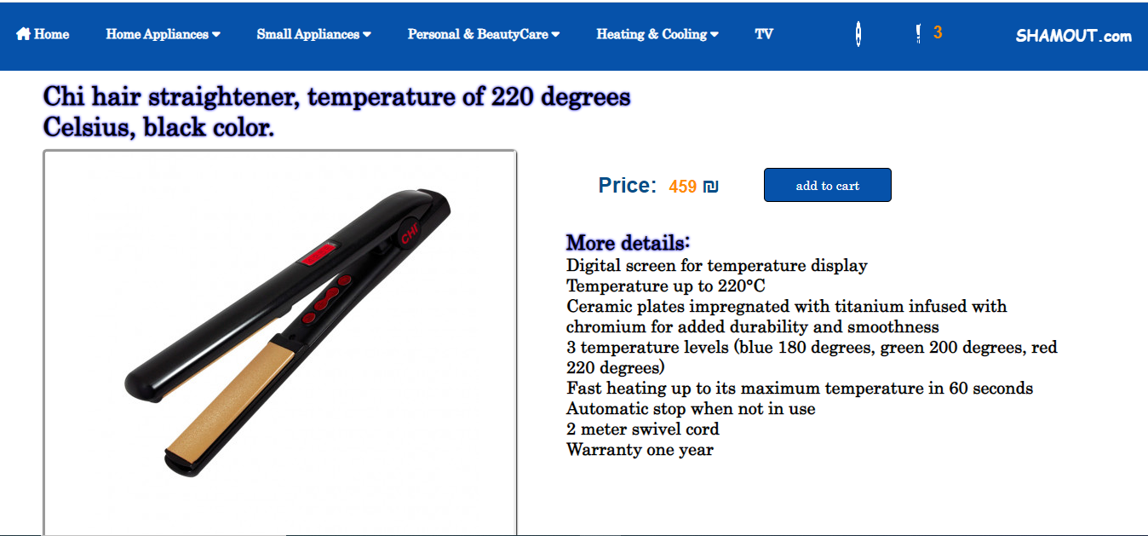

* Men razors:

In this website we show our Men razors in all brand:

* 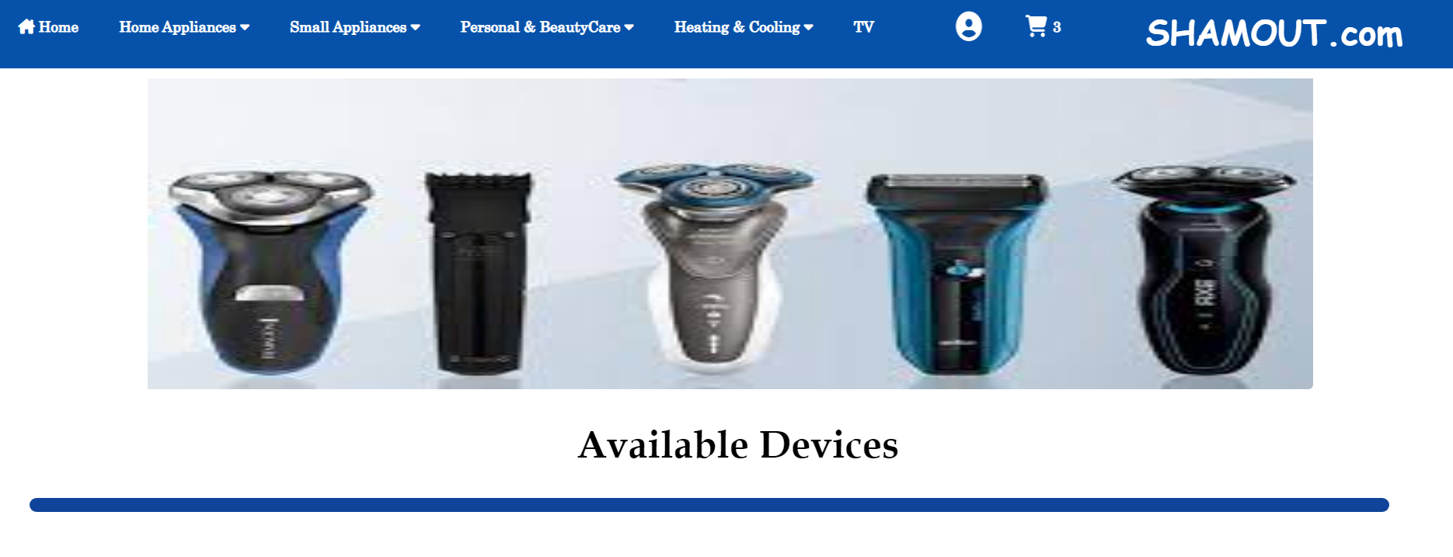

And if we scroll down:

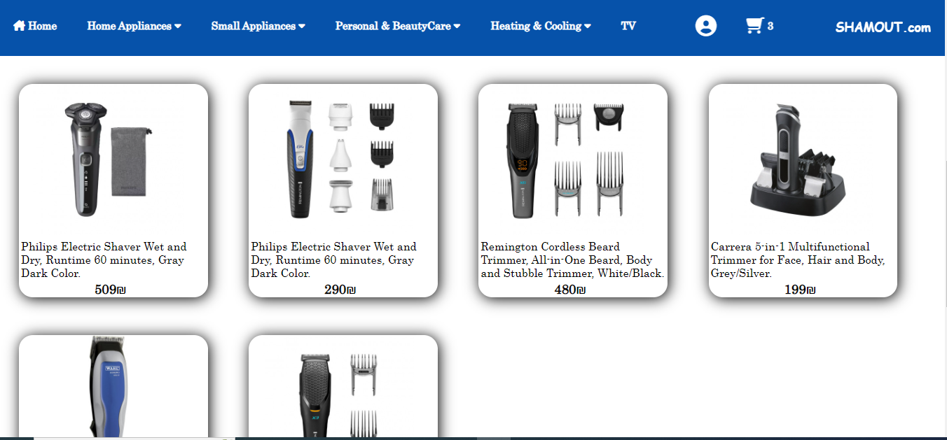

When mouse over on image in card:

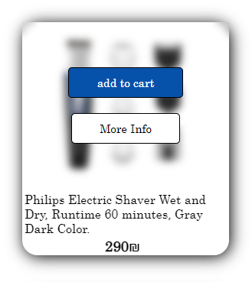

When click on add to cart Button if the item doesn’t already found in shopping cart this item will added to the shopping cart and show a message.

But if the item is already found in shopping cart then will show a message that the item is already found in the shopping cart. But if user want to increase the amount of item he can increase the quantity in shopping cart.

And when click on more information will go to the item page, this page has more details about the item and also when click on add to cart Button this item will added to the shopping cart.

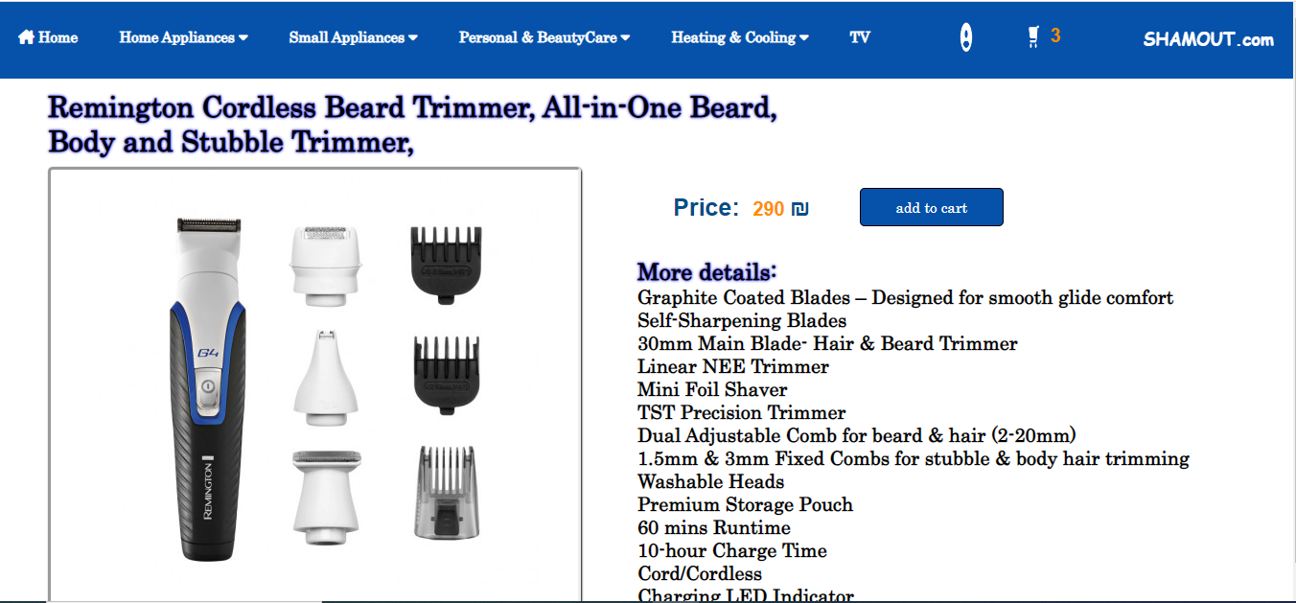

4-Heating & Cooling

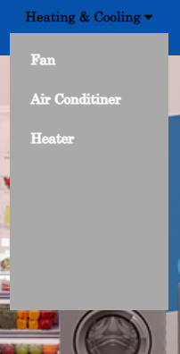

* Fan: 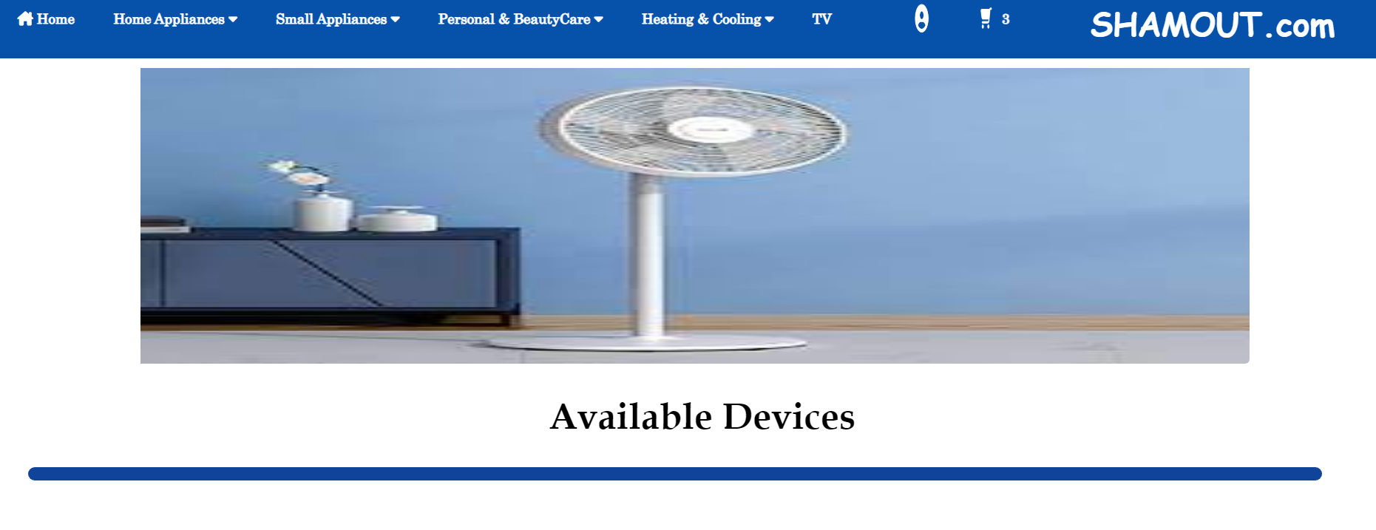

In this website we show our Fan in all brand:

And if we scroll down:

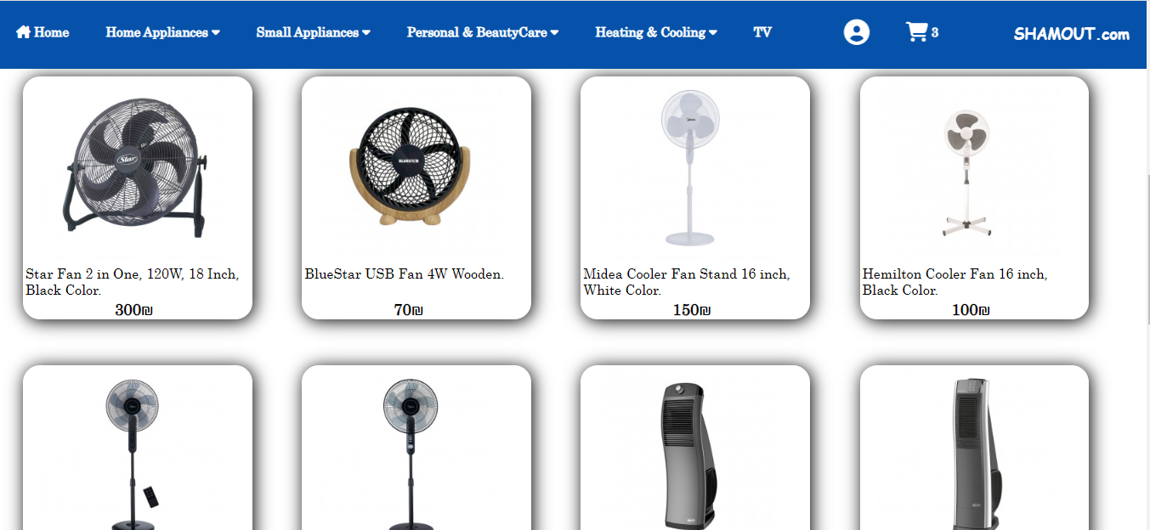

When mouse over on image in card:

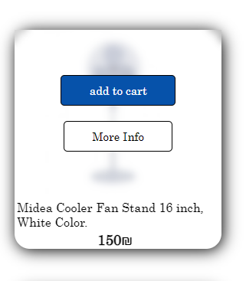

When click on add to cart Button if the item doesn’t already found in shopping cart this item will added to the shopping cart and show a message.

But if the item is already found in shopping cart then will show a message that the item is already found in the shopping cart. But if user want to increase the amount of item he can increase the quantity in shopping cart.

And when click on more information will go to the item page, this page has more details about the item and also when click on add to cart Button this item will added to the shopping cart.

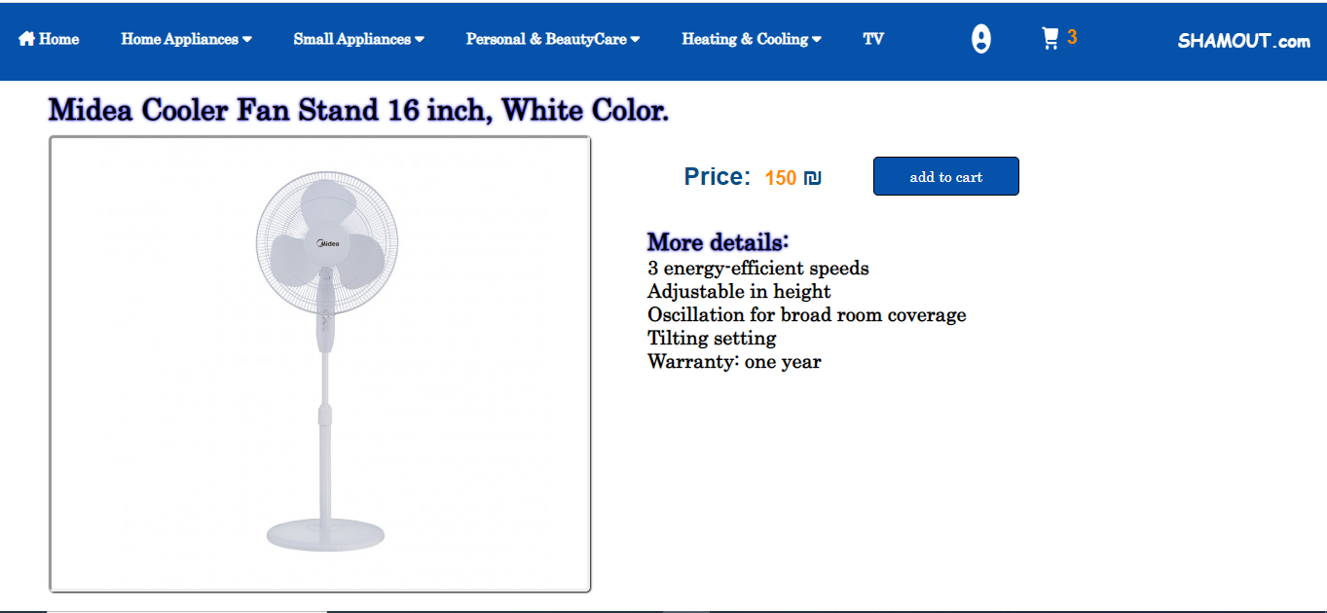

* Air Conditioner:

In this website we show our Air Conditioner in all brand:

* 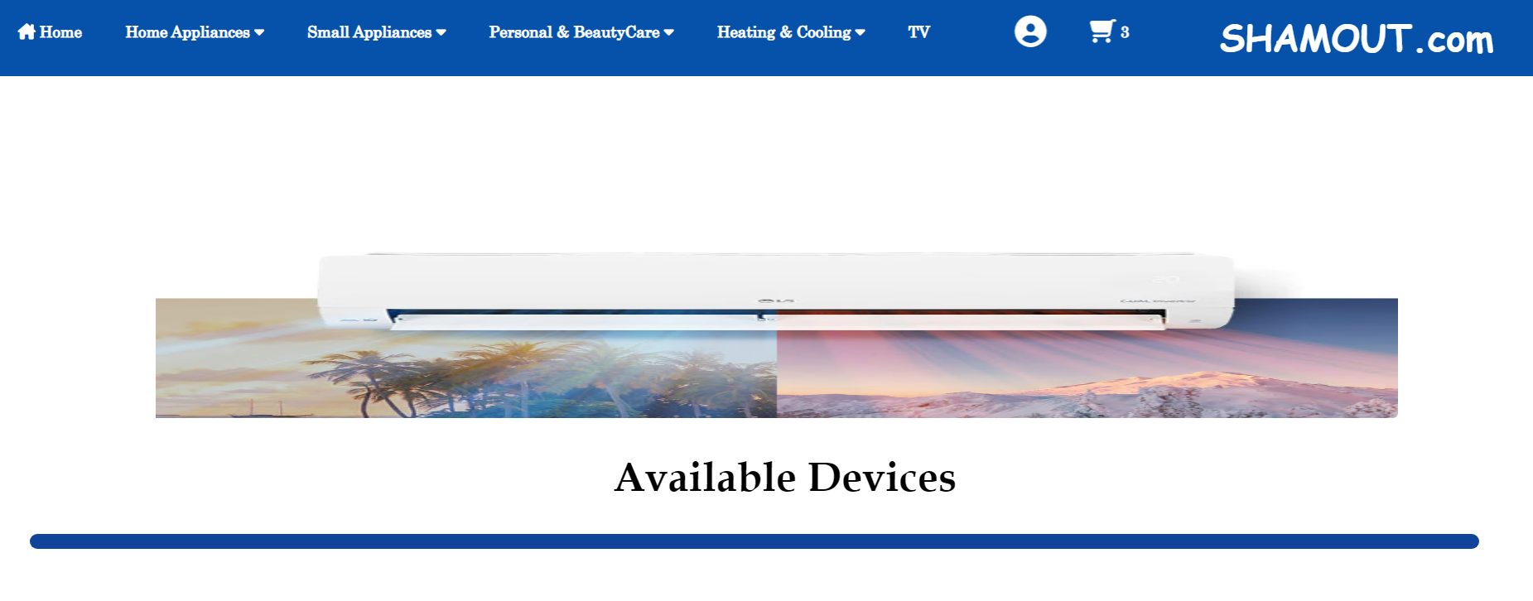

And if we scroll down:

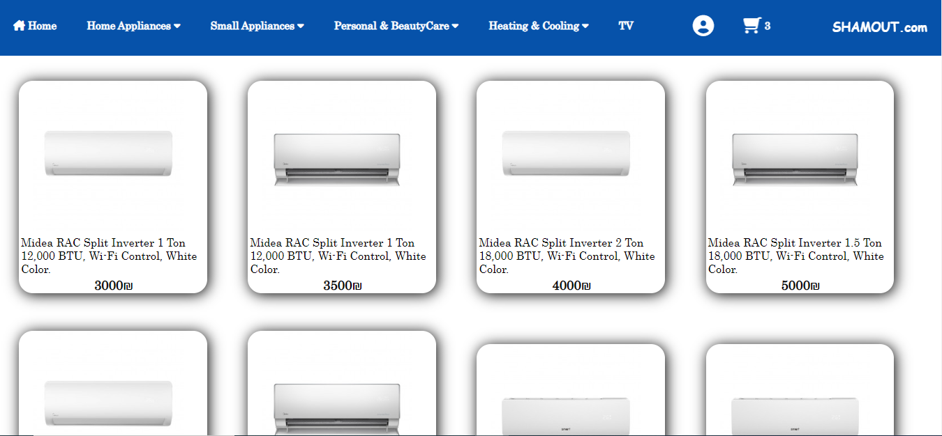

When mouse over on image in card:

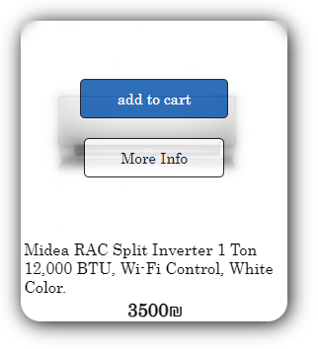

When click on add to cart Button if the item doesn’t already found in shopping cart this item will added to the shopping cart and show a message.

But if the item is already found in shopping cart then will show a message that the item is already found in the shopping cart. But if user want to increase the amount of item he can increase the quantity in shopping cart.

And when click on more information will go to the item page, this page has more details about the item and also when click on add to cart Button this item will added to the shopping cart.

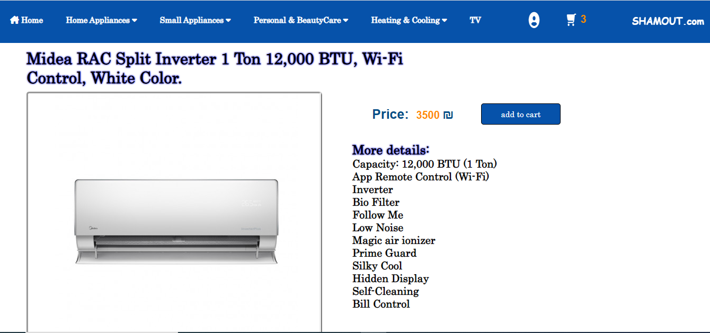

* Heater:

In this website we show our Heater in all brand:

* 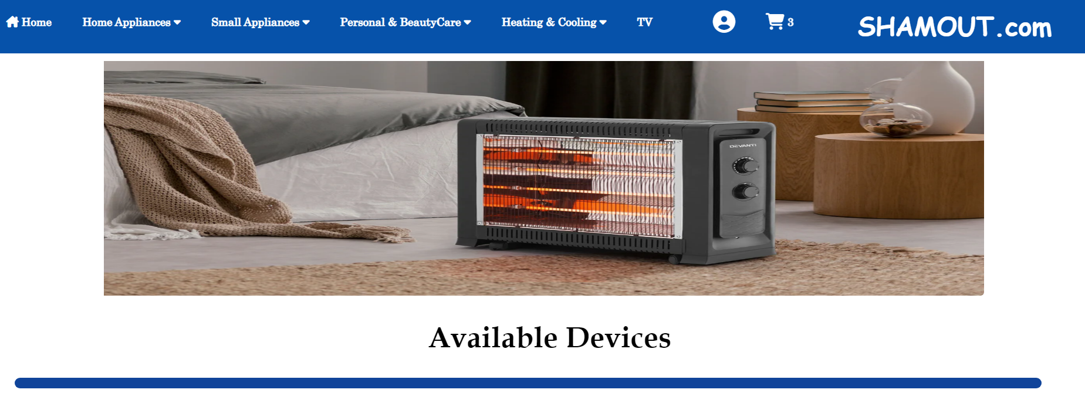

And if we scroll down:

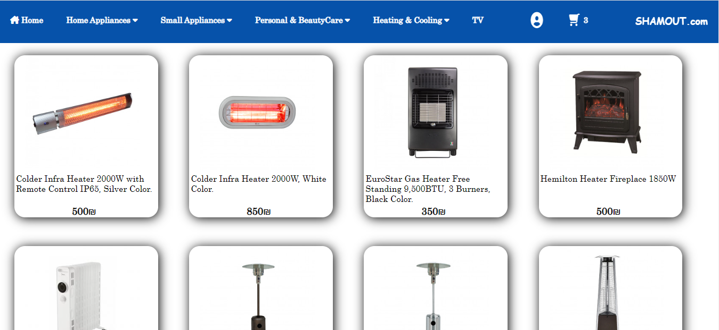

When mouse over on image in card:

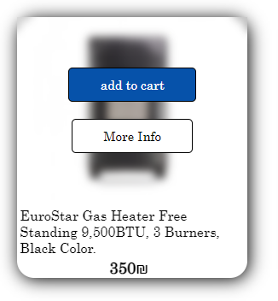

When click on add to cart Button if the item doesn’t already found in shopping cart this item will added to the shopping cart and show a message.

But if the item is already found in shopping cart then will show a message that the item is already found in the shopping cart. But if user want to increase the amount of item he can increase the quantity in shopping cart.

And when click on more information will go to the item page, this page has more details about the item and also when click on add to cart Button this item will added to the shopping cart.

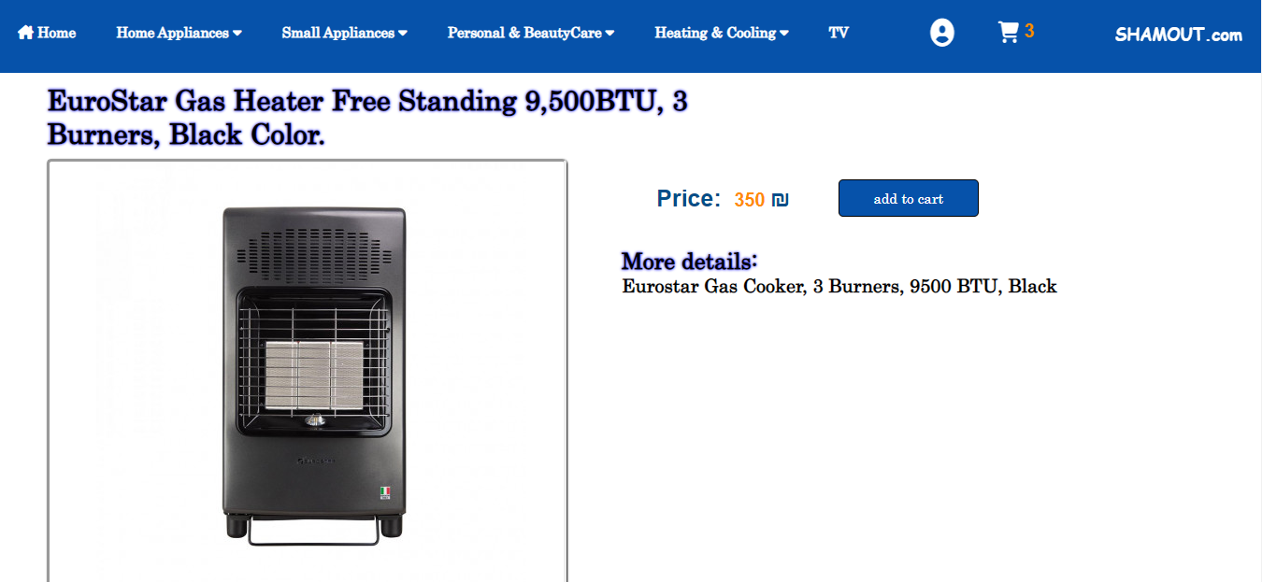

5-TV:



In this website we show our Heater in all brand:

* 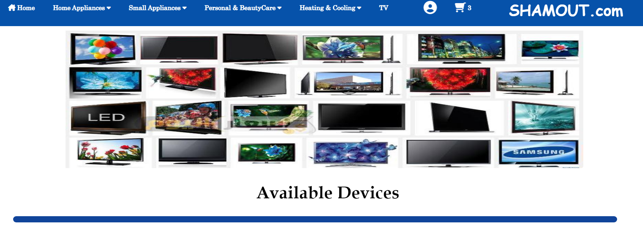

And if we scroll down:

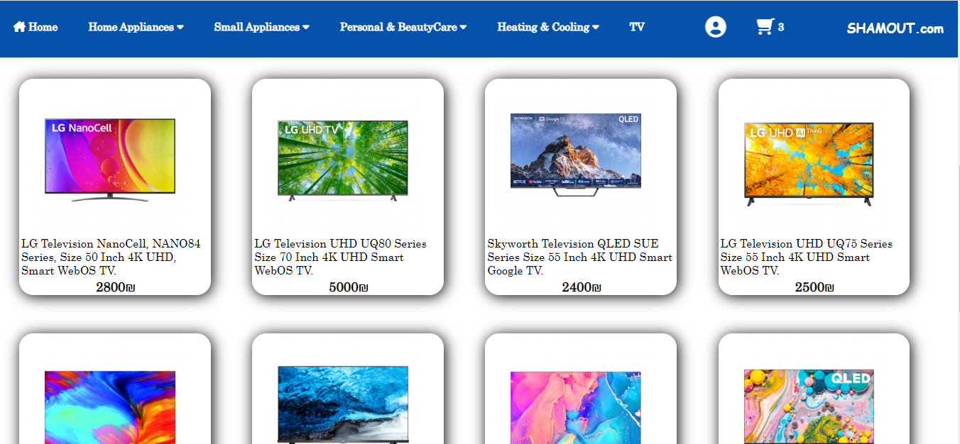

When mouse over on image in card:

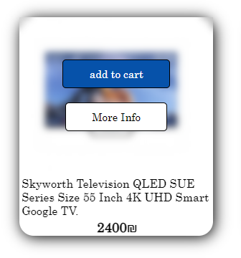

When click on add to cart Button if the item doesn’t already found in shopping cart this item will added to the shopping cart and show a message.

But if the item is already found in shopping cart then will show a message that the item is already found in the shopping cart. But if user want to increase the amount of item he can increase the quantity in shopping cart.

And when click on more information will go to the item page, this page has more details about the item and also when click on add to cart Button this item will added to the shopping cart.

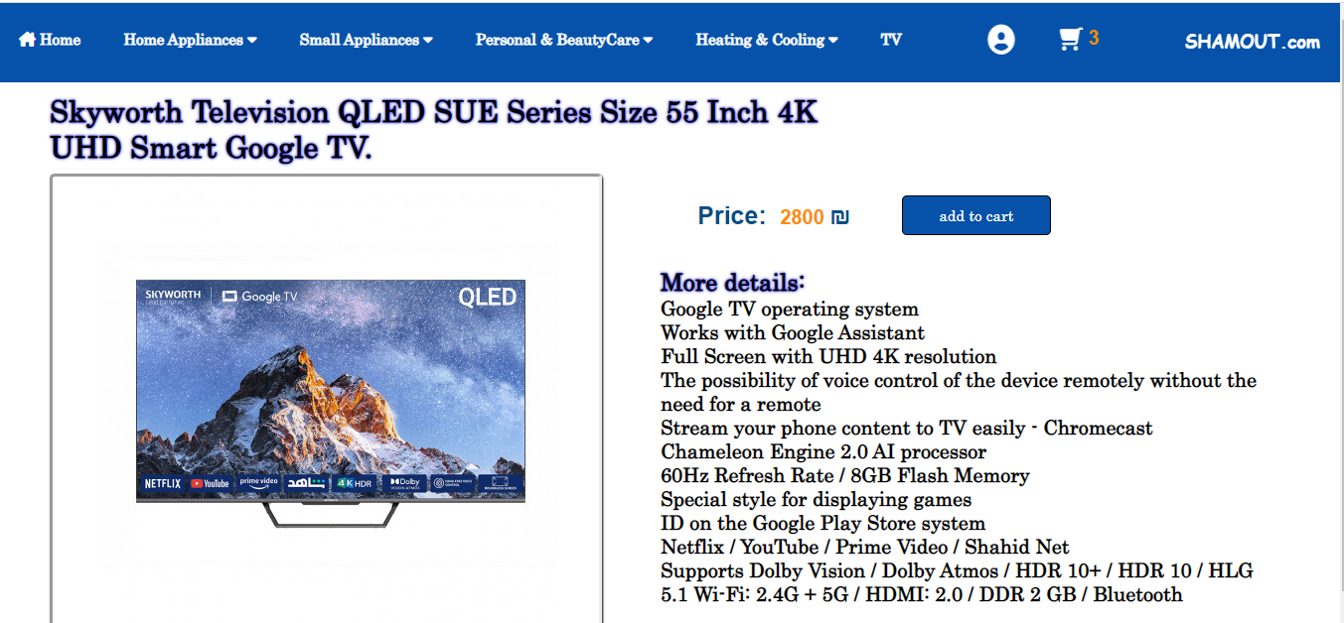

Shopping cart page

When click icon cart

 (after finish shopping or show product which has been added) this page apper like this

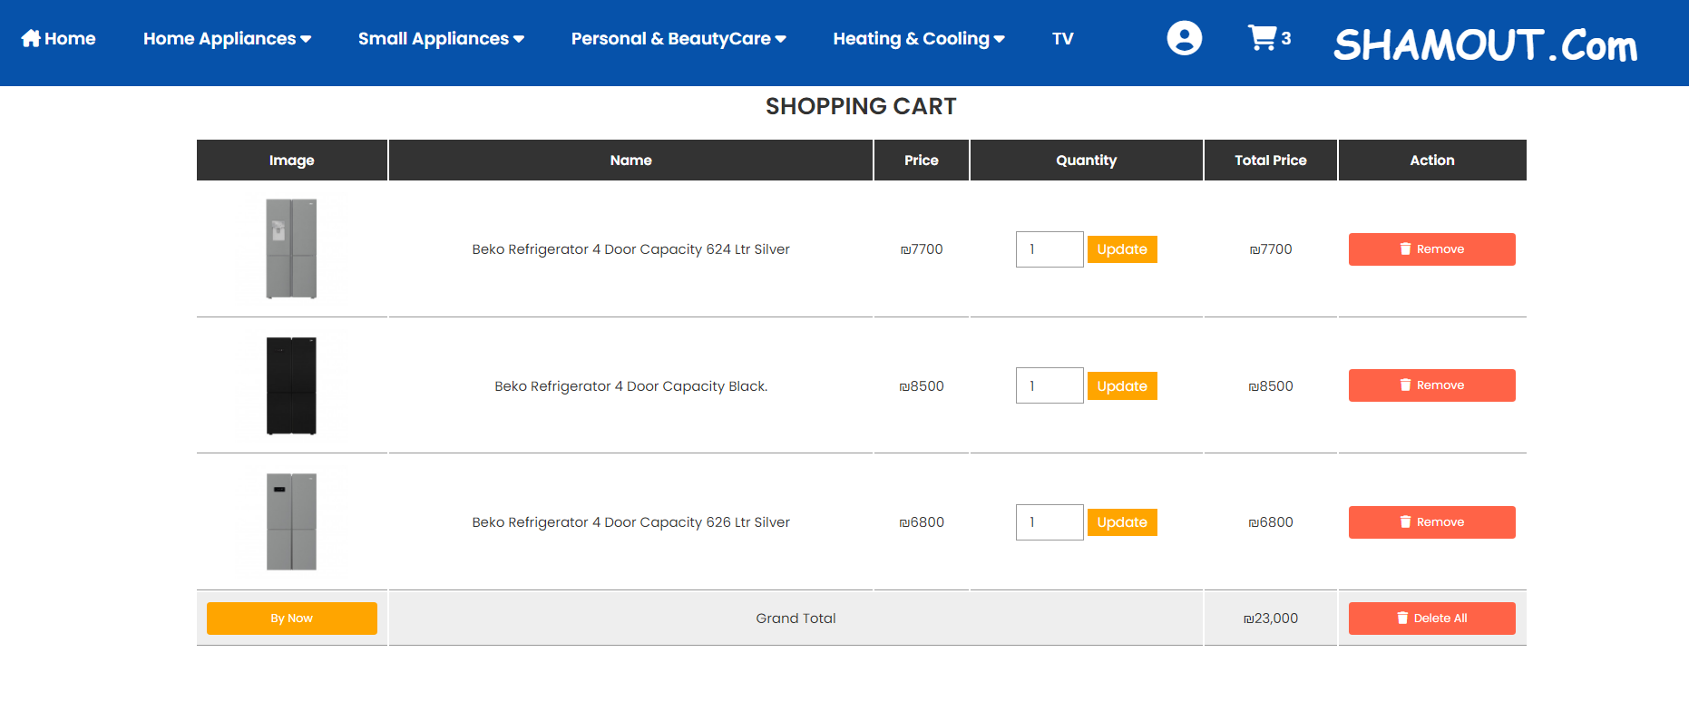

Through this page, the image of the product that was chosen, the name, the price, the quantity, and the total price appear. The user can also delete a product that he did not want, delete all products, or modify the quantity of the product then click update. Upon completion and confirmation of all products, the user clicks on By now to go order page.

order:

When user click on Bye now Botton will go to order page to fill all information need to deliver the order correctly.

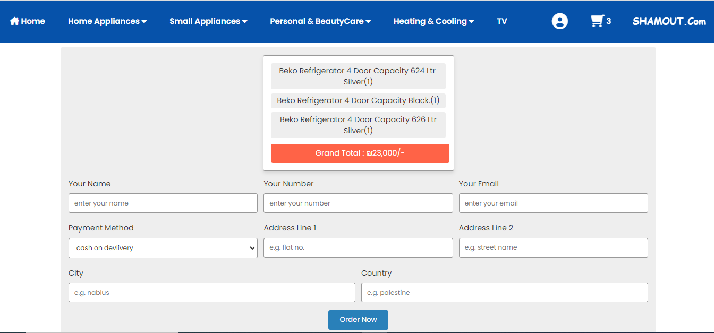

User should fill all fields before click on order now, if he doesn’t fill any of them and click on order now the message “please fill out this field” will shown

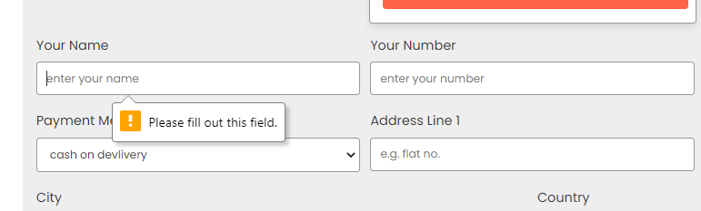

And when click on order now this page will show:

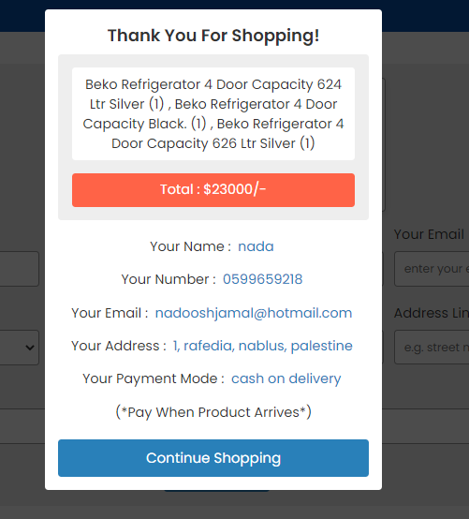

When click on continue shopping will go to home page “Shamout.php”

* **Conclusion:**

We learned how to generate HTML elements using three methods which are PHP and javascript.

About backend side, we learned how to manage the database using MySQLi object which allows us to make different queries such as select, insert, update and delete.

-**REFRENCES:**

1. **Web course by Dr.Sufyan Samara.**

2.**Youtube**

3.**MySQL**

https://dev.mysql.com/doc/

4.**W3Schools**:

https://www.w3schools.com/